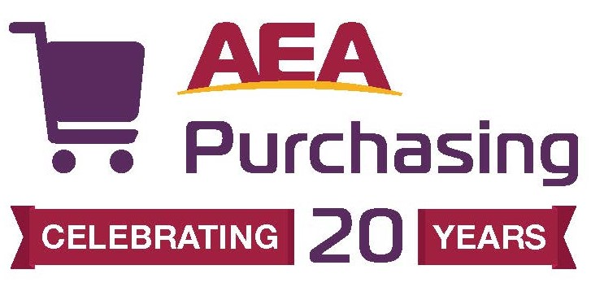
ATTACHMENT 1: VENDOR WORKSHEET
PaperWin1920
Instructions: Please complete this worksheet using the text boxes provided. Upload the completed worksheet to Public Purchase as part of your bid submission.

Vendor Name:

Company Information
Please give a very brief company background and history. Please include the length of time the product you are bidding has been available from your company.

Return Policies
State your return policy (full refund, restocking charge, etc.).

Late Payment Fees
Describe your policy for late payment fees.

Customer Service
Is customer and/or technical support available via:
Toll free number (provide number): | YES or NO
Email (provide address): | YES or NO
Online help and support: | YES or NO
Support material available for download: | YES or NO
Instant messaging support/chat: | YES or NO

List customer/technical support hours (central time zone).

Please list all additional customer service value added services you will provide if awarded this contract.

Sales and Marketing
Describe in detail the staffing (physical locations, territories, etc.) that will be in place to accommodate AEA Purchasing
members.

Provide your company’s plans to communicate with AEA Purchasing members regarding this opportunity.

References
Provide three (3) K-12 references (preferably in Iowa) for whom you have provided a similar service to (cut paper).

Name
Address
Email
Phone Number

Name
Address
Email
Phone Number

Name
Address
Email
Phone Number

Please provide the total number of K-12 districts you currently support.

What is your current client retention/return customer rate?

Sales to AEA Purchasing Membership/Potential Clients
REQUIRED: Accredited public, nonpublic and private schools and entities with whom AEAs have a contract (PK-12)

Will the following “potential clients” be eligible to receive contract pricing under this RFP?

Non-accredited educational entities without contracts with the AEAs (i.e. Head Start, preschools) | YES or NO
City, county and state government | YES or NO
Public Libraries | YES or NO
Community Colleges, Public Universities and Colleges, Private Colleges, Iowa Department of Education | YES or NO
Parents, home school parents/groups, teachers | YES or NO

Geographic Capabilities
Are you able to service the entire state of Iowa?

If not, provide detail on your coverage area. See ATTACHMENT 4 for a map of AEA service areas.

Pricing
Vendors must submit a completed pricing schedule -- ATTACHMENT 3A and 3B.
An administrative fee will be paid to AEA Purchasing as illustrated in Chapter 1 and 3.

Competitive Pricing
Prices will be the same as those we offer on single school district bids. | YES or NO
Prices will be better than we offer on single school district bids. | YES or NO
Prices will be the same as those we offer to cooperatives and state purchasing officers. | YES or NO
Prices will be better than we offer to cooperatives or state purchasing officers. | YES or NO

Warehousing Facilities
Describe your automated order process. How are orders placed, picked and shipped?

What is the time frame schools can expect from order to delivery (i.e. next day, 2 days)?

Ordering Process
Describe your capabilities for schools placing orders (i.e. fax, online, e-mail). If you offer online ordering, will your company be able to provide an “AEA Purchasing” ordering site?

Minimum Order
Will there be a minimum order requirement for AEA Purchasing members?

Environmental Responsibility
Please explain any efforts your company is demonstrating to be environmentally responsible.

Iowa Production
Are any of your products and/or provisions produced within the State of Iowa? If so, please explain.

This document was completed by:

Name and Title (Please print)
Signature
Phone number
Email
Date

