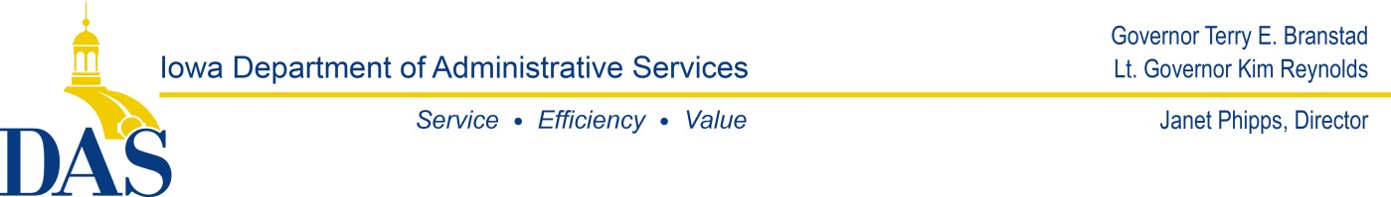

April 3, 2018

To: All Potential Bidders RE: RFB0518583193 – AV Upgrade for Two Conference Rooms –Change in Bid.

**Amendment One**

The Department of Administrative Services formally issues amendment in the AV Equipment Criteria.

Line 1.4 paragraphs 2 of the Background Information states:

Iowa Homeland Security and Emergency Management located at 7900 Hickman Rd. Suite 500, Windsor Heights, IA 50324 have two conference rooms needing AVI equipment purchased and installed. There currently is no existing equipment in the conference rooms to be removed. Attached (RFB Conf Rms AV Equipment list) is a check list of equipment the Agency will like to have purchased and installed. Bidders are to enter the complete price of the total in the bid line and Bidder must attach a break out of each item to this bid. This break out must include manufactures and product models.

The correction to be made is on the first line where it states “two conference rooms needing AVI equipment. The line should state AV (audio/video) equipment. This bid is not seeking any particular models of equipment. In the RFB0518583193 attachment (Conf. Rms AV equipment list) is a list of the types of equipment needed in the conference rooms.

The business, AVI has not be involved in any planning or designing of the audio/video needs for these two conference rooms.

Respectfully submitted by,

Randy Bennett, Purchasing Agent

Iowa Department of Administrative Services Hoover State Office Building – 3rd Floor 1305 East Walnut St., Des Moines, IA 50319 Phone: 515/725-2925

Email[: randy.bennett@iowa.gov](mailto:randy.bennett@iowa.gov) **|** Website: [http://das.iowa.gov](http://das.iowa.gov/)

