Attachment F
Iowa Child Care Resource and Referral Regions
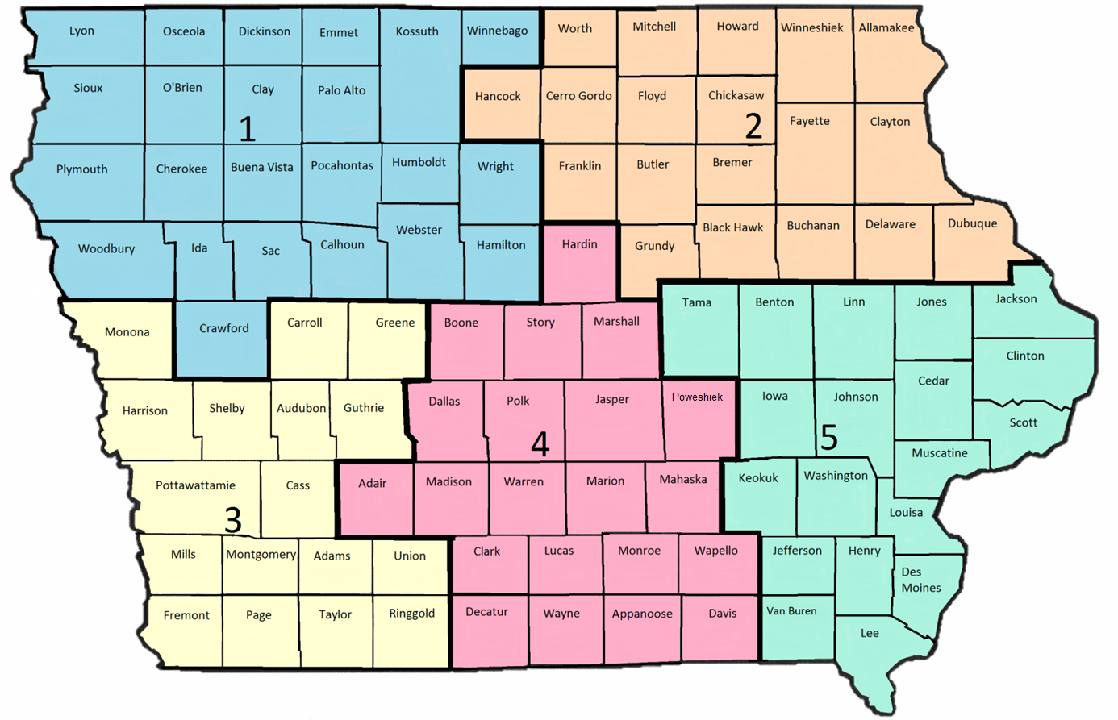

Region 1 | Region 2
Counties Served:  Buena Vista, Calhoun, Cherokee, Clay, Crawford, Dickinson, Emmet, Hamilton, Humboldt, Ida, Kossuth, Lyon, O'Brien, Osceola, Palo Alto, Plymouth, Pocahontas, Sac, Sioux, Webster, Winnebago, Woodbury and Wright | Counties Served:  Allamakee, Black Hawk, Bremer, Buchanan, Butler, Cerro Gordo, Chickasaw, Clayton, Delaware, Dubuque, Fayette, Floyd, Franklin, Grundy, Hancock, Howard, Mitchell, Winneshiek and Worth
Region 3 | Region 4
Counties Served:  Adams, Audubon, Carroll, Cass, Fremont, Greene, Guthrie, Harrison, Mills, Monona, Montgomery, Page, Pottawattamie, Ringgold, Shelby, Taylor and Union | Counties Served:  Adair, Appanoose, Boone, Clarke, Dallas, Davis, Decatur, Hardin, Jasper, Lucas, Madison, Mahaska, Marion, Marshall, Monroe, Polk, Poweshiek, Story, Wapello, Warren and Wayne
Region 5
Counties Served:
Benton, Cedar, Clinton, Des Moines, Henry, Iowa, Jackson, Jefferson, Johnson, Jones, Keokuk, Lee, Linn, Louisa, Muscatine, Scott, Tama, Van Buren and Washington

