Statement of Work For
Herbicide Control
IOWA AIR NATIONAL GUARD BASE, DES MOINES, IOWA

1. DESCRIPTION OF SERVICES. The contractor shall provide all management, licenses,
laboratmy testing, tools, reporting, supplies, equipment, transportation and labor to conduct Herbicide Control at the Iowa Air National Guard Base, Des Moines, Iowa (hereafter Base) in a manner that will ensure the health and general well-being of installation personnel.

- The contract Period of Performance is for ONE YEAR.

- LOCATION: 3100 McKinley Avenue, Des Moines, Iowa 50321. Highlighted areas on attached map are for general idea. Site visit will be required. A site visit can be scheduled with Civil Engineering between 8:00 A.M. and 2:30 P.M. Monday through Friday. Contact Ryan Jones (515) 261-8705 or Tim Mulligan (515) 261-8703 for scheduling.

- SCHEDULE OF WORK: The Contractor's representative shall inform Ryan Jones at 515- 261-8705 or Kyle Koeper at 515-261-8704, in advance, with a proposed work schedule to insure prompt access to the work area. Normal duty hours are Monday through Friday 7:00
A.M. to 3:30 P.M. Contractor shall be responsible for his own security of materials and equipment.

- APPLICABLE REGULATIONS :
  - The Contractor shall comply with all (but not limited to) applicable rules, codes or laws stemming from the Environmental Protection Agency (EPA), Code of Federal Regulations (CFR), Occupational Safety and Health Administration (OSHA), Federal Insecticide, Fungicide, and Rodenticide Act (FIFRA), state/local regulatory guidance. DOD 4150 .07, DOD Pest Management Program, and AFI 32- 1053, Pest Management Program.
  - Installation Regulations. The Contractor and his/her employees shall become acquainted with and obey all Government regulations, as posted or as requested by Civil Engineering. The Contractor shall comply with all federal, state, and installation environmental, safety, bio-environmental, occupational health, and security regulations and requirements.
  - The Contractor shall generate each usage report using the DD Form 1532-1 for each visit, provided and required by the Government. Each usage report shall be provided in hard copy the day of application and an electronic file within 3 days following the application.
  - The Contractor shall be required to have on file licenses issued by the Iowa Department of Agriculture for each employee who will perform duties on Base. No unlicensed employee shall be allowed to perform applicator duties without a licensed applicator to supervise the task.

  - The Contractor shall also be required to ONLY use those materials identified on the Armed Forces Pest Management Board (AFPMB) listing dated 1 October 2017. The listing is attached to this statement of work. Should the Contractor recommend materials other than on the list, a submission of the new materials Safety Data Sheet (SDS) and Label will be required for approval prior to its use on the Base.
  - Materials and application rates: After reviewing the Armed Forces Pest Management Board (AFPMB) standard pesticide list the Contractor shall submit a listing of all proposed pesticides/herbicides for final approval by Civil Engineering (see Table 1 for the list). All application methods and rates as prescribed in accordance with the product label will be followed. Before departing the installation the contractor will fill out the Department of Defense Form 1 532-1 (see Form 1 ) and submit it to Civil Engineering on each visit.
- PERFORMANCE: All work shall require coordination with the Iowa Air National Guard Civil Engineering Squadron and will be inspected to ensure the work performed meets the expectation of the contract. The Contractor, at no additional cost to the Government, will process any/all work rejected as a result of these inspections. The Contractor shall perform their work in a manner that will not interfere with or stop operations being conducted in and around the work area.

- SAFETY AND FIRE: The Contractor shall take all necessary precautions for proper safety standards and fire prevention, and will adhere to all safety and fire regulations of the State and Federal Codes. In addition, the Contractor shall conform to any restrictions as may be outlined by the Base Safety Officer or Environmental Manager during the contract. Special care will be taken to prevent accidental poisoning by pesticides and to prevent damage by pesticides to vegetation, buildings, automobiles or other objects. All pesticides or other toxicants will be secured with lock and key when left unattended in a vehicle. No pesticides or emptied containers will be dumped, left un-attended or disposed of in any manner likely to cause injury or contaminate the environment. They will not be placed in .dumpsters or trashcans. Under no circumstances will pesticides be left with building occupants, or other persons in areas treated or to be treated. The contractor, according to federal and state
Regulations, will accomplish disposal of empty pesticide containers off the base per regulatory compliance.

- CONTRACT ITEMS

  - Submission of a bid by a contractor shall be accepted as evidence that they have read the work scope and have satisfied themselves as to the nature and location of the proposed work and all matters which can in any way affect the work or cost under this contract.

  - Insurance. Within I5 days after the award of this contract, the Contractor shall furnish the KO a CERTIFICATE OF INSURANCE as evidence of the existence of the insurance as specified by the Government.

- BASE PROCEDURES
  - Badges: All Contractor employees shall obtain the required security badge. The Contractor shall, prior to the start of the contract, submit to Civil Engineering the

Information required for the Entry Authority List. The Government (Security Police) will issue badge(s) when the Contractor enters the Base. Each employee shall wear the Government-issued badge over the front of the outer clothing while on the Base. The badge will be returned to Security Forces when the Contractor leaves the Base.

  - Identification of Contractor Vehicles. The Contractor Company Name shall be displayed on each of the Contractor's vehicles in a manner and size that is clearly visible. All vehicles shall display a valid state license plate and safety inspection sticker, if applicable, and shall be maintained in good repair. All vehicles shall also provide insurance requirements upon entry to the base. All vehicles must post signage on all four sides that pesticides/herbicides are present on the vehicle. All products being transported
in the vehicle at the time entry onto the Base will have current accompanying Safety Data Sheets (SDS).
  - Check In/Check Out Requirements. The Contractor's project manager shall check in at Building 410 or call Ryan Jones at 515-261-8705 or Kyle Koeper 515-261-8704, prior to the commencement of each day's work and check out at the completion of each day's work. At the time of check in/check out, the project manager shall indicate: ( I ) the services planned to be provided during the day; (2) the location of the planned services;
(3) planned services that were not completed during the day; and (4) schedule of proposed follow-up treatments identified during the day. Before departing the installation the contractor will fill out the Department of Defense Form 1 532- 1 (see Form 1 ) and submit it to Civil Engineering on each visit.

Table I . Armed Forces Pest Management Board (AFPMB) Standard Pesticides List

ARMED FORCES PEST MANAGEMENT BOARD (AFPMB) STANDARD PEST1CIDES LIST AVAILABLE TO DOD COMPONEXTS AND AGENCIES

October 1, 2017

NSN
6840-
It•m (Alteruaiin Trade Nome} :'110:\ Unit Pack.1ge AAC" Price
Codt
Unit Users+
Issue

00-001-7710  SDS label | Herbicide, 40% bromacil, 40% diuron, granular \•ar I DF) | C2,C! | 6-lb bag | H | 12751 | BG | A, N, F,  M
01-630-350 1  SDS label | Herbicide, 40% bromacil, 40% diuron, granular (Kro\0ar I DF) | Cl,Cl | 15 lb. bag | z | 29U5 | BG | F
01-3.56-600 1  SDS label | Herbicide, Fluridone, 5%, pellets (Sonar SRP) | Fl | 40-lb co | J | 646.37 | co | A,N
01-356-8888  SDS label | Herbicide, Fluridone 41.7% liquid (Sonar A.S.) | Fl | I qt co | H | 117145 | QT | A,N
01-525-5869  SDS label | Herbicide, Imazapic ammonium salt 23.6% liquid (Plateau) | B | (2) !-gal co | J | 1427.63 | BX | A, N, M, F
01-108-9578  SDS label | Herbicide, lsopropy!omine salt of glypho<a!e, 41%, water soluble liquid (RoWJdup ProtRan2er Pro/Razor Pro!Glvfos Pro) | G | (2) 2.S-ga! co | H | 187.12 | BX | A,R F,  M
01-388-0142  SDS Label | Herbicide, lsopropylamine salt of glypho•ate, 41%, wate1 soluble liquid (Row1dup ProtRani;er Pro/Razor Pro!Glvfos Pro) | G | 30-gal dmm | H | 1160 .?7 | DR | A,, F, N
01-156-8893  SDS Label | Herbicide, lsopropylomiue salt of glyphosate, 53.S%, water soluble liquid (Rode01RoW1d11p·Cwtorn) | G | (2) 2.S -gal co | H | -132..ll | BX | A, F,M,  N
01-377-7 113  SDS Label | Herbicide, lsopropylamine salt of glyphosate, 1.0%,  Pelargonic, acid 2.0% (RolUldup Readyct0-Use) | G | 24 -oz pump  spray bottle | H | 8.81 | BT | N. F
01-399-0673  SDS Label | Herbicide, Ammonimn sali of g!yphosate, 73. 3% and 2 .9%  Dfouat dibromide, (Quik Pro) | G,D | 5 pkg | H | 12.67 | BX | A,F, M
01-545-4540  SDS label | Herbicidf', Ammonimn salt of glyphosate. 7l3% and 2.9% Diauat dibromide, (Quik Pro) | G,D | 6.8 lb. co | H | 1t9.65 | co | A, N, M,  F
01-356-8902  SDS Labe.I | Hexbicide, Isoprnpylamine salt ofirnazapyr, 26.7% (Arsenal P<nwrlin<') | B | (2) 2.5-gal.co | H | 2898.94 | BX | A, N, F,  M
01-532-5403  SDS label | Herbicide, lsopropylamine salt of!rnazapyr, 27.7% (Habitat) | B | (2) 2.S-gal co | H | 107.70 | BX | A, N, M
01-318-7417  SDS label | Herbicide, Oryzalin, 40.4% (Surflan A.S.) | Kl | (2) 2.5-gal co | H | 389.68 | BX | A, N, F,  M
00-145-0013  SDS label | Herbicide, Prometon, 25% prometon, ernubifiable concenimte (Pramitol 25E) | Cl | (2) 2.5-gal co | H | 306.68 | BX | A, F, N
01-356-889 1  SDS Label | Herbicide, Sulfometuron meth}1, 75% (Oust XP) | B | 48-oz C-0 | H | !79.Si | co | A, N, M
01-319 1890  SDS Label | Herbicide,Tebuthiuron, 80% (Spike 80 DF) | C2 | 4-lb bag | J | !38.42 | BG | A, N, F
01-457-6576  SDS Label | Herbicide, Tebuthiuro11-Di11ron, 1% Tebuthiurou, 3} Diurou  (Somiril SK-13) | C2 | 40 1b.  container | H | :?2732 | co | A,. N, M
01-552-1821  SDS Label | Herbicide, Triclop}'f, 60.45% (Garton 4 Ultra:) | 0 | (2) 2.5-gal co | H | 683.42 | BX | A, N, M,  F
00-577-4194  SDS label | Herbicide, 2.4-Dichloropheuoxy-acetic acid (2,4-D), 67.2% oil miscibleiwater t'llluls ifiable li<l uid {low volatile ester form} | 0 | (2) 2.5-gal co | H | 196.7 | BX | A, N, M
00-664-7060  SDS Label | Herbicide, 2.4-Dichlorophenoxy -acetic acid (2,4-D), 46.8% water soluble liquid (amine 5alt form) | 0 | (2) 2.5-gal co | H | lH.Oi | BX | A, N, M
01-377-7110  SDS Label | He.rbicide, 2,4-Dichlorophenmry-acetic acid (2,4-D), 0.118%, 0.22% Mecoprop-p and 0.05% Dicamba water soluble liquid (Weed-B-Gon) | 0 | 24-az pump spray bottle | H | 11.57 | BT | F, N

Form I . DD Fo1m 1532-1

TYPE OF
Date
Units
Stt1vicE<d
Work Origin
Unit of
Meawre
Target
Pest
Control Operation
If Pe:stidde is Used
Labor Time
A:ppli- cator lnitials
Nam
EPA
% Cone
Amount
I
BUILDING/AREA SIZE CONSTRUCTION

USE DESIGNATION

Form Approv•d. OMB No. 0704-0188 REPORT CONTROL SYMBOL: PEST MANAGEMENT MAINTENANCE RECORD
The. public reporting b.m:fe:n: fo.r tN: cotlection Gf infonn:tticf\ i; e::timet.d to eve-rege 4 hour :pe.r -re-2. 'inc:IUd ing time for re-vie.wing. in=truction;:, ::eard'mg exhtin9 date :ource::, qsthr:riog
and main! ning the data needed , and compkting mld -revievnng the coUe of infounetkm . nd comment. regarding tl-.b bu«k.ri e:titc> or .:iny othet e.:pect of thh CoUection of W.c-rme:tion.
; tiola , ,.'! t!jb t : ;1, f;;.gOe : ; c ';,f; o a C. cu; va Mec! n:iing :irry
PlfASE 00 NOT ftf:TllR N YOUR FORM TO THE.ABOVE ORGAN ZATION.

MEASUREM ENT UNTS.

OR!GtN OF WORK

TYPE Of CONSTRUCTION

MSF = l,000 e f eet MCF 1.000 cubK f
t.Ff" = line¥ fff!t
AC ;"""''
&Vt.r = Gcheddoed wcxl.: SC: = NK:o or tToui»e c.:iff W'R =· Wod. requoe•t R =' Routine-: in:>pec::tfon
:CO = Cancre e
El = Block
B'V = Bric;k: veneer
r>T = Gtte-1, :::heet metl:H
'i/tlO = Wood
OT = Odler

DD FORM 1532-1, AUG 96 Reset

Date | Unit; Serviced | \:\'ort  Origin | Unit. :of Mea 5utB | Target  Pe"St | Control Operat>on | "If P tkide fa Utoti |  |  |  | Labor Time | Appl cator l'nitials
 |  |  |  |  |  | Name | EPA Reg | % Cone | Amount
REMARKS
DD FORM 1532-1 !BACK). AUG 96 .------...,--. (Attach addirional c.ard to continue record}
Reset

1,160' FENCE LINE

1,700' FENCE LINE
200' BUILDING EXTERIOR
75' BUILDING EXTERIOR
360' BUILDING EXTERIOR
330' BUILDING EXTERIOR
63,700 SQ.FT. OF PARKING AREA
1,700' FENCE LINE

41O' BUILDING EXTERIOR

2,080' FENCE LINE
200' BUILDING EXTERIOR

360' EDGE OF PAVING
2,700 SQ.FT. GRAVEL

640' BUILDING EXTERIOR
4,260 SQ.FT. MULCH BED USE SOMETHING THAT WILL NOT AFFECT THE TREES AND ITS FRUIT.
640,410 SQ.FT. OF A IRCRAFT PARKING

Ii=
0
w.,""!
"'"'
111..1
aci:
ai:Z
<l:Ow
:::>i=:::i
l:lci:z
..IZW
<1:111: ><1:
zwci::i:
2 >0
1--w-
ffli::i
::!: ai:Zli!Z
w <2 o

1,760' FENCE LINE
ecln:
"3':"::'Jg:.:E,

88,900 SQ.FT. OF PARKING AREA

770' FENCE LINE
m 2o

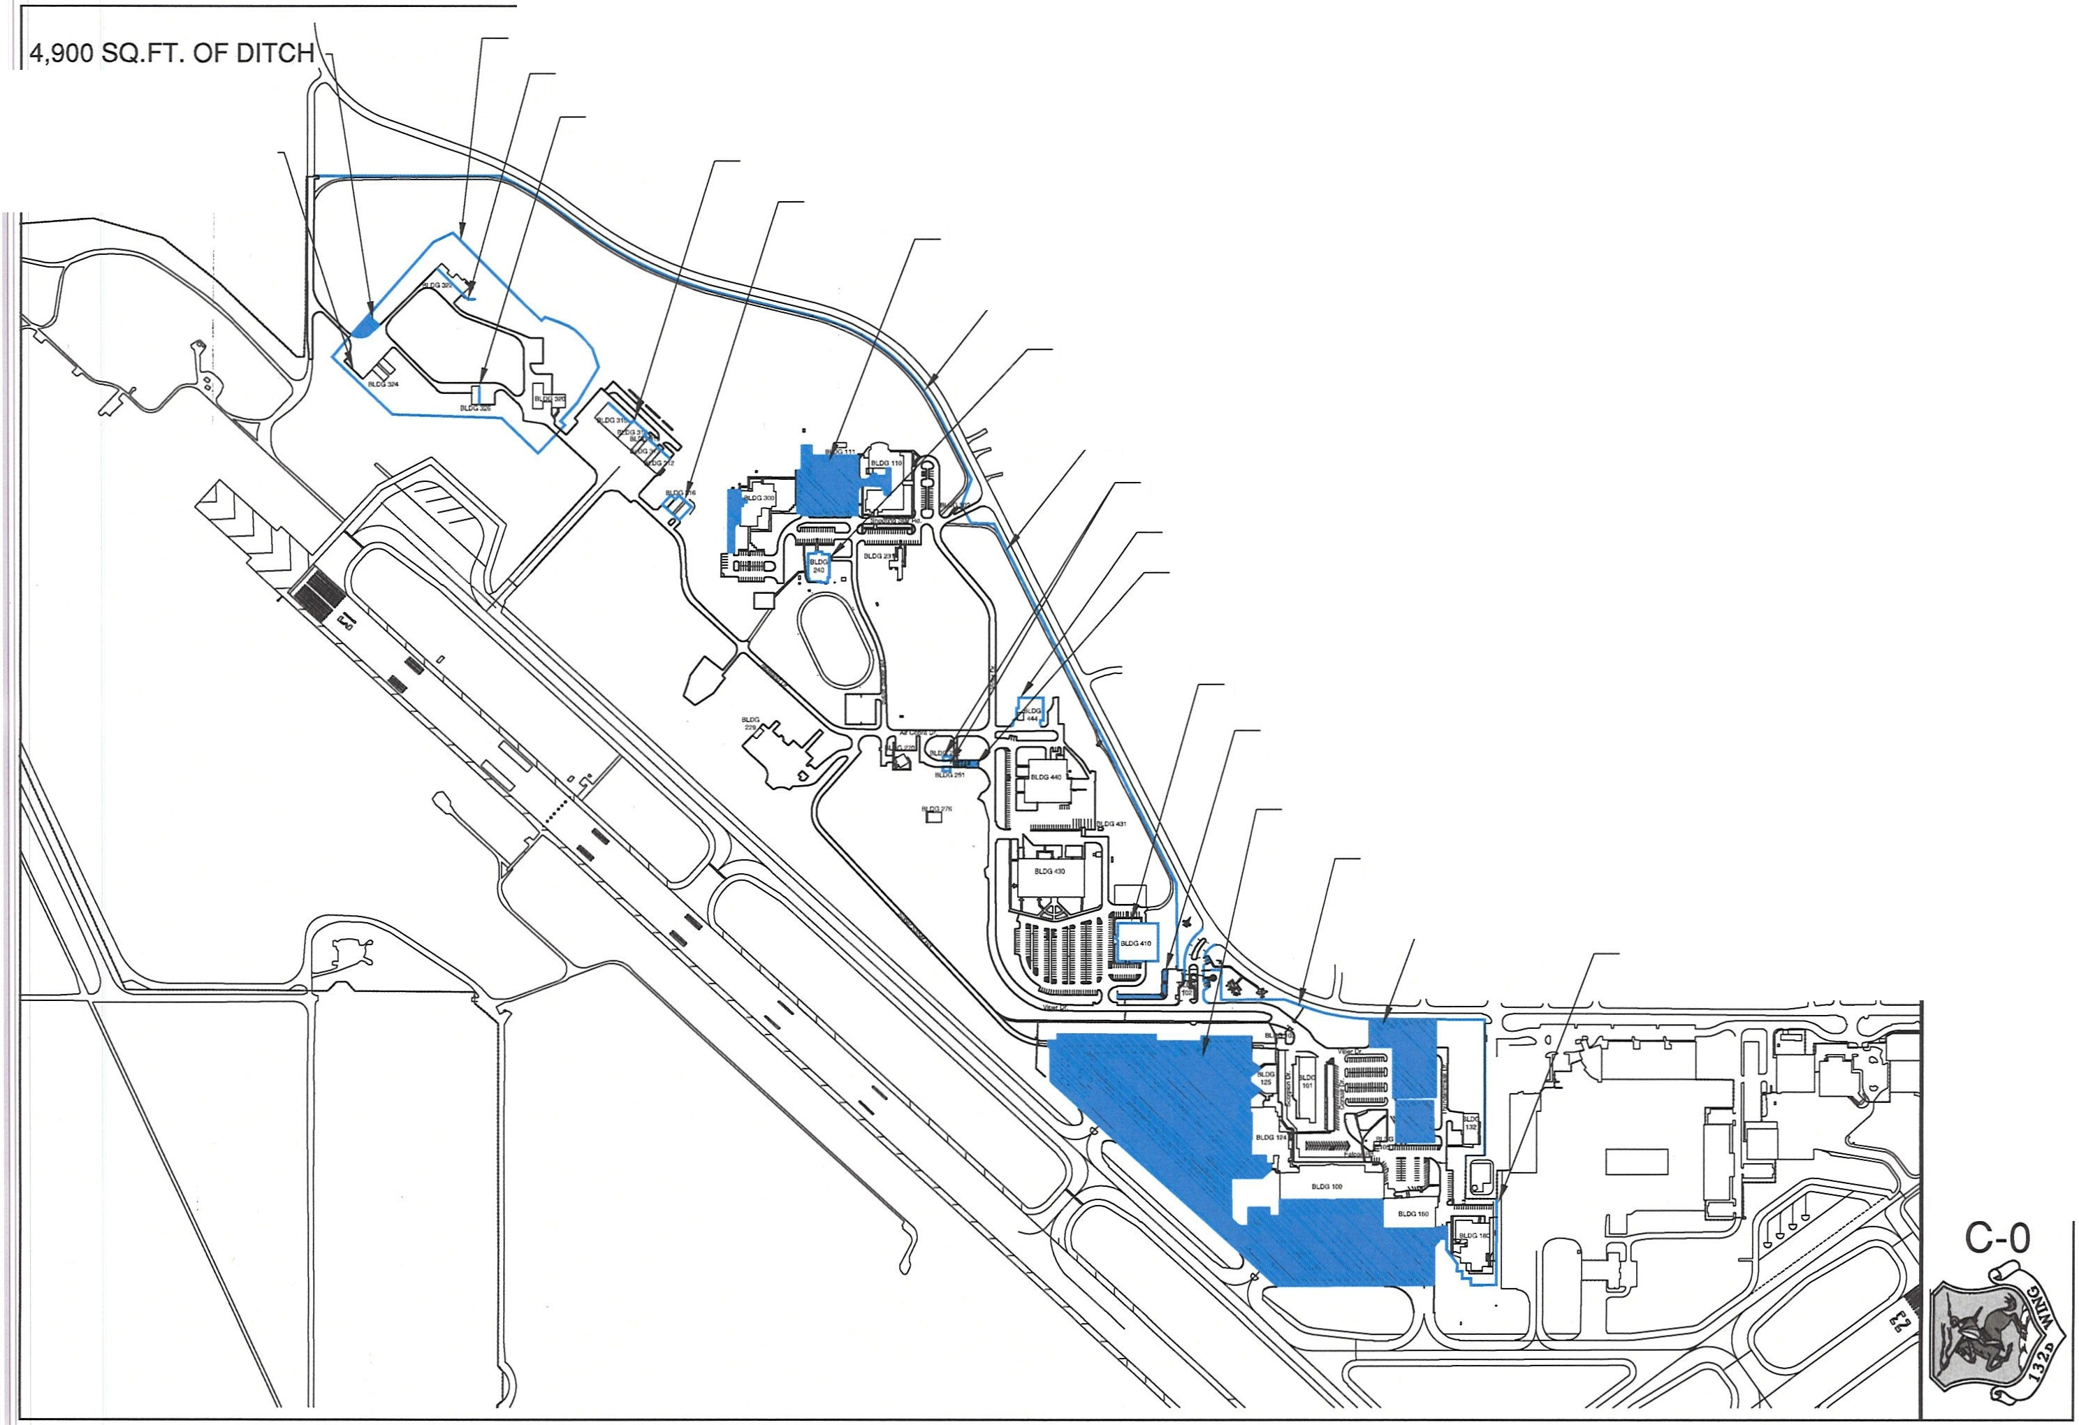

H
i
Project Number:

Shoot:

CERTIFICATE OF SITE VISIT

This is certification that:

PERSON

FIRM

Visited the job site for verification of conditions/measurements/equipment at:

FACILITY LOCATION

DATE

CONTRACTOR' S SIGNATURE

FACILITY REPRESENTATIVE SIGNATURE

This "Certificate of Site Visit" must accompany your proposal.

