REQUEST FOR QUOTES (RFQ)
for
Clear Lake - SWG Mowing and Tree Pulling
19CRDWBTHERR-0005

The Department of Natural Resources (DNR) is seeking a Service Provider to mow two (2) different prairie reconstructions up to three (3) times each during the 2019 growing season and one (1) time during the 2020 growing season at times designated by DNR staff and pull trees for 135 hours at various Wildlife Management Areas (WMAs) in North-Central Iowa. DNR anticipates that the term of any resulting contract will be June 1, 2019 through December 31, 2020. Service Providers may not contact any employee of the State of Iowa about this Informal RFP other than the DNR Issuing Officer:
T.J. Herrick, Wildlife Biologist
Iowa Department of Natural Resources - Wildlife
PO Box 360
Ventura, IA 50482
Fax: 641-829-3285
E-mail: tj.herrick@dnr.iowa.gov

If a Service Provider or someone acting on a Service Provider’s behalf attempts to discuss this RFQ orally or in writing with any members of the DNR, any employee of the State of Iowa, or anyone other than the named DNR Issuing Officer, then the Service Provider may be disqualified.

Submission of Quotes: Service Providers interested in providing the services described under the “Description of Work and Scope of Services” shall submit quotes to the DNR Issuing Officer no later than 4:00pm CST on April 29, 2019. Any quote received after this deadline shall not be considered.

Only written quotes received via hand delivery, e-mail, fax or hard copy mail using the form labeled “Service Provider Cost Proposal – DNR RFQ #19CRDWBTHERR-0005” included in this RFQ will be accepted.

Service Providers may submit written questions regarding this RFQ and the procurement process to the DNR Issuing Officer at the above address through 4:00pm CST on April 25, 2019. Written responses to any questions received will be provided no later than April 28, 2019 to all potential Service Providers.

Description of Work and Scope of Services: Successful Service Provider shall mow each of the following prairie reconstructions up to three (3) times each during 2019 growing season and one (1) time during the 2020 growing season at the times designated by Iowa DNR Project Manager. Additionally this project will require the pulling of small trees/shrubs with a skid-steer mounted tree puller.

County Wildlife Management Area/Location Size/Amount
Winnebago - Mowing Hogsback WMA - Langesen Tract 44 acres
Norway Township, Section 9
Nearest Intersection – 510th ST & 210th AVE

Winnebago - Mowing Hogsback WMA - Langesen Tract 64 acres
Norway Township, Section 9
Nearest Intersection – 500th ST & 210th AVE

Winnebago, Worth, Hancock Various Wildlife Management Area 135 hours
Cerro Gordo – Tree Pulling

Statement of Work. Contractor shall perform the following Tasks, to be completed at the following regular intervals.
Deliverables | Task Milestone Date
Task 1: Prairie Reconstruction Mowing  Description: Contractor shall mow the areas identified on the map labeled as “Attachment A & B” up to three (3) times during the 2019 growing season and one (1) time during the 2020 growing season. Mowing shall be done with a commercial rotary type mower.  Task 1a: Establishment Maintenance Mowing  Spring/Summer 2019: Mow 108 acres  Mow at a height of 8 to 12 inches.  Task 1b: Establishment Maintenance Mowing  Summer 2019: Mow 108 acres  Mow at a height of 8 to 12 inches.  Task 1c: Establishment Maintenance Mowing  Summer 2019: Mow 108 acres  Mow at a height of 8 to 12 inches.  Task 1d: Establishment Maintenance Mowing  Spring/Summer 2020: Mow 108 acres  Mow at a height of 8 to 12 inches.  The DNR Project Manager will provide the Contractor a minimum of 72 hour notice before mowing is required. | This task will be completed on an as needed basis, up to three times, as directed by DNR Project Manager. The DNR Project Manager will provide a minimum of 72 hour notice prior to mowing being required.
  County | Wildlife Management Area | Acres to Mow | Total Acres
  Winnebago | Hogsback WMA – Langesen Tract | 64 | 256
  Winnebago | Hogsback WMA – Langesen Tract | 44 | 176
  Grand Total |  | 108 acres | 432 acres
Task 2: Pull Trees with Skid-Steer Mounted Tree Puller  Description: The Contractor shall pull all tree/shrubs <4” and >1“ diameter on various WMAs in Winnebago, Worth, Hancock or Cerro Gordo County. Contractor will provide 135 hours of tree/shrub pulling in area identified in “Attachment C”. | No later than December 15, 2020.

Minimum Qualifications/Equipment Specifications: The DNR will not evaluate minimum qualifications/equipment specifications but does expect documentation to be provided with the “Service Provider Cost Proposal – DNR RFQ # 19CRDWBTHERR-0005”. The following are minimum qualifications required for this project:
- Knowledge and expertise in, but not limited to, mowing native prairie plantings and pulling trees and /or shrubs with a skid-steer mounted tree puller.

Source of Funding: The source of funding for the Contract entered into from this RFQ is State Wildlife Grant.

Acceptance of Contract Terms and Conditions: By submitting a response, each Service Provider acknowledges its acceptance of the terms and conditions of the contract template “DNR Standard Contract Conditions” and “General Conditions” found at http://www.iowadnr.gov/About-DNR/RFP-Bid-Lettings.

If a Service Provider takes exception to a contract provision, then the Service Provider must state the specific exception and the reason for the exception, and must attach to its “Service Provider Cost Proposal” the specific contract language it proposes to include as an alternative to the provision. Contract provision exceptions that materially change the terms or the requirements of this informal bidding process may be deemed non-responsive by the DNR, as determined in its sole discretion, resulting in possible disqualification of the Service Provider’s quote. With regard to the “DNR Standard Contract Conditions,” DNR and the successful Service Provider may agree to modifications to the terms of the “DNR Standard Contract Conditions” as necessary to negotiate the terms of a contract. A Service Provider’s failure to state an exception to any contract provision and propose alternative language may be deemed by the DNR to constitute the Service Provider’s acceptance thereof. The State reserves the right to refuse to enter into a contract with the successful Service Provider for any reason, even after delivery of notice of selection or intent to award a contract.

Additional information: The costs of preparation and delivery in response to this RFQ are solely the responsibility of the Service Provider.

DNR reserves the right to reject any or all submitted responses, in whole or in part, to advertise a new RFQ, to abandon the need for such RFQ, and to cancel this RFQ opportunity at any time prior to the execution of a written contract.

All information submitted by a Service Provider may be treated as a public record by the DNR.

By submitting a response, a Service Provider agrees that it will not bring any claim or have any cause of action against DNR or the State of Iowa based on any misunderstanding concerning the information provided within this RFQ or concerning the DNR or the State of Iowa’s failure, negligent or otherwise, to provide the Service Provider with pertinent information as intended by this RFQ.

If the apparent successful Service Provider fails to negotiate and deliver an executed contract within a reasonable period of time following selection, then the DNR may, in its sole discretion, cancel the award and award the contract to the next highest ranked Service Provider.

The DNR shall have the sole option to amend the contract resulting from this RFQ for subsequent periods, adding up to no more than six years total from the beginning date of the original contract, by executing a signed amendment prior to the expiration of the original contract.

Evaluation Criteria: Quotes will be evaluated and the contract awarded to the responsible Service Provider submitting the lowest priced quote.

Service Provider Cost Proposal – DNR RFQ #19CRDWBTHERR-0005

The Service Provider quote shall include an all-inclusive, total cost in U.S. Dollars (including all travel, expenses, etc.) to provide the requested services. All pricing to be FOB Destination, freight cost included; and based on Net 60 Days Payment Terms. All fees expected for payment are to be included in this bid.

Quote for Tasks:
Task | Unit Cost |  | Time Frame | Total Cost
Task 1: Prairie Reconstruction Mowing  Quantity: 432 acres  (108 acres mowed up to 4 times) | Hogsback WMA – Langesen Tract  $ / acre |  | This task shall be completed on as needed basis, up to 3 times in 2019 and 1 time in 2020, as directed by DNR Project Manager | Hogsback WMA Total  (108 acres up to 4 times)  $
Task 2: Tree Pulling  Quantity: 135 hours | $ / hour |  | Task shall be completed at a time directed by DNR Project Manager | Tree Pulling for a period of 135 hours (no travel charges will be paid)  $
Grand Total |  |  |  | $

Documentation is attached for DNR verification that the Service Provider meets the “minimum qualifications/ equipment specifications” listed in the RFQ.
Signature:
Date:
Printed Name and Title:
Name of Contractor Organization:
Address:
Phone: |  |  |  |  |  |  |  | E-mail:

Attachment A
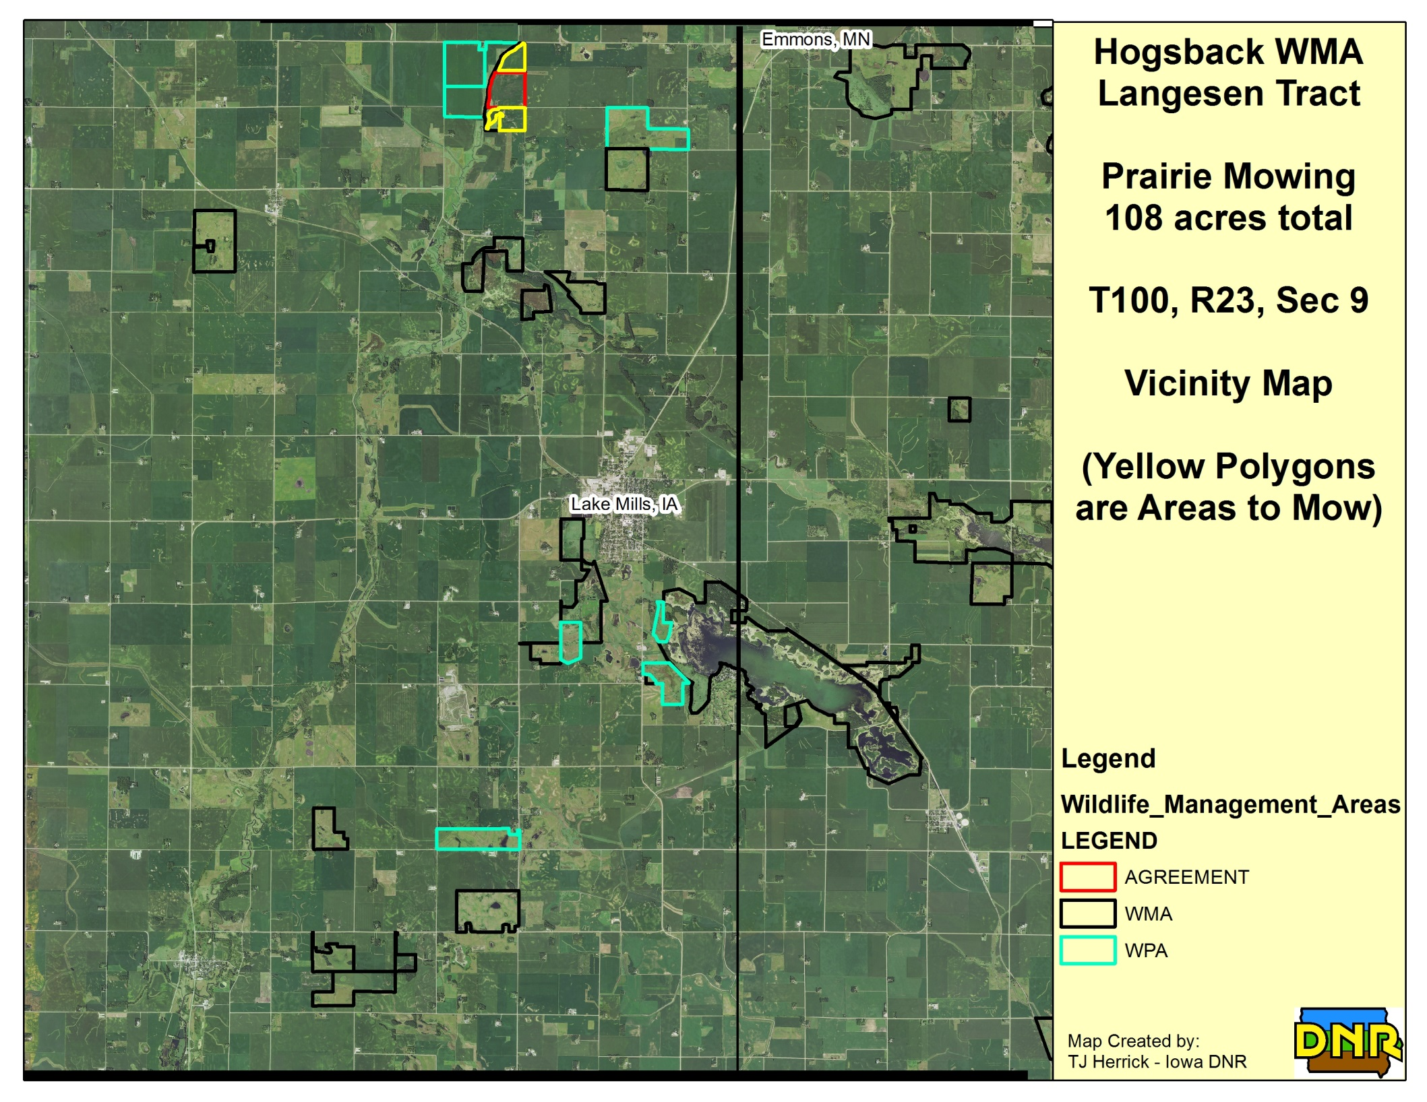
Attachment B
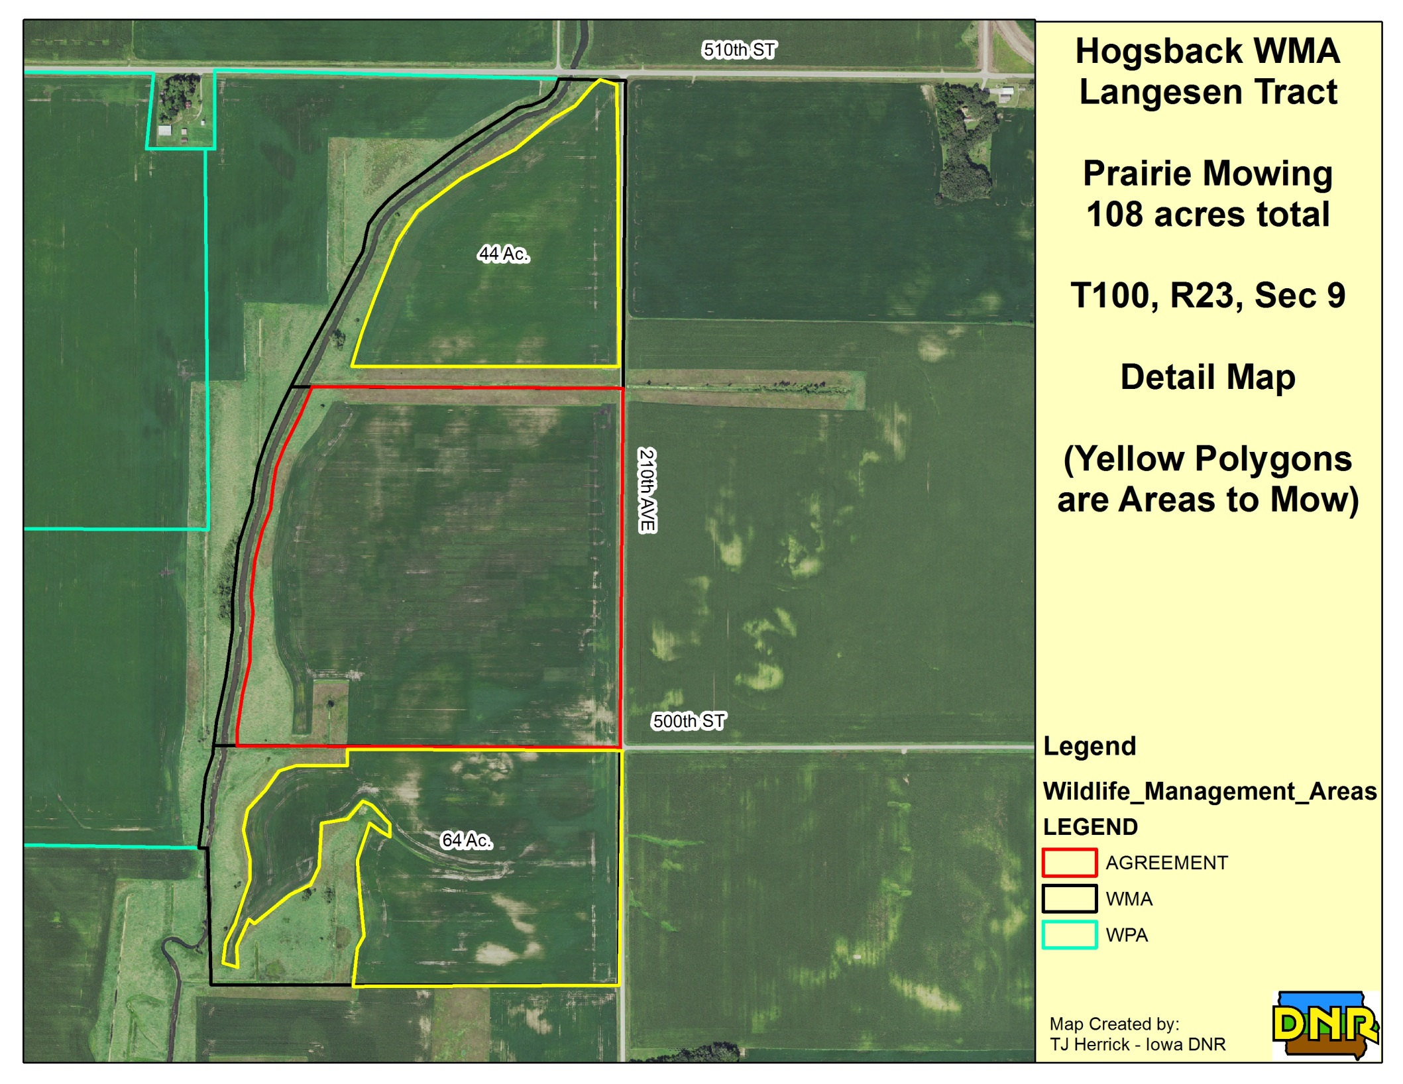
Attachment C
