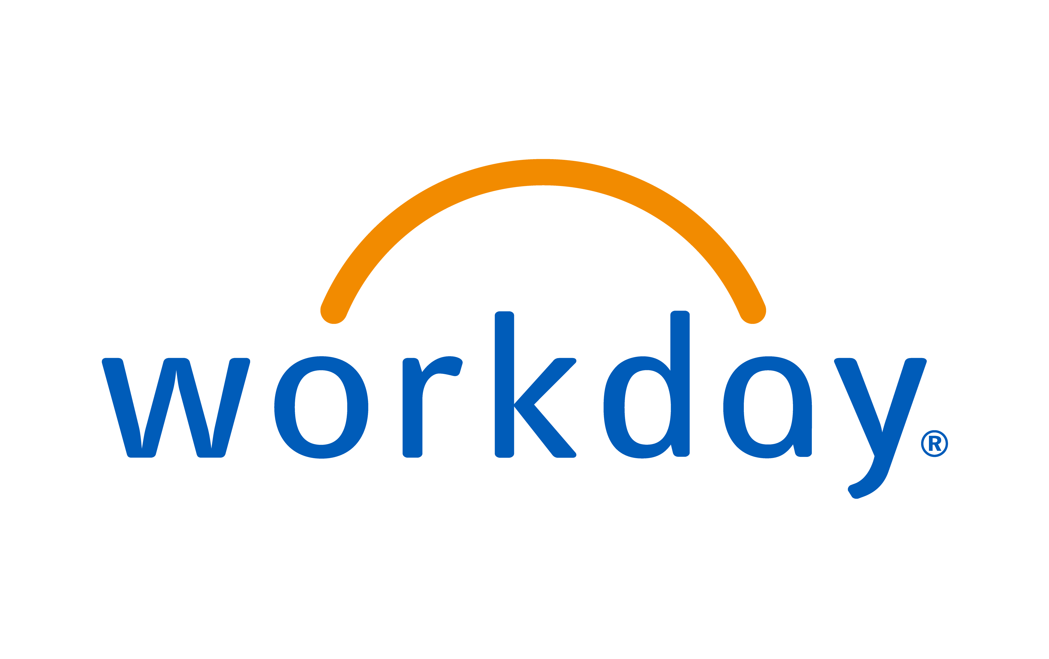

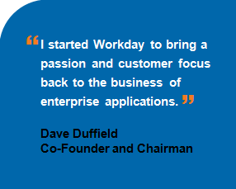

***Today, competitive pressures require innovative software solutions. Enterprise applications built on technology developed more than ten years ago cannot keep pace with today’s business environments. Those applications are rigid and inflexible and require that customers make large upfront investments for software, hardware, middleware, database, and professional services, and then suffer through elongated implementations and complex, costly upgrades. Alternatively, Workday’s cloud solutions offer a fresh approach to legacy ERP.***

Workday is a leading provider of enterprise cloud applications for human resources and finance. Founded in 2005, Workday delivers Human Capital Management, Financial Management, and analytics applications designed for the world’s largest organizations. Hundreds of companies, and Education and Government organizations, ranging from medium-sized businesses to Fortune 50 enterprises, have selected Workday.

We achieved this leadership position through our innovative and adaptable technology, focus on the consumer Internet experience and cloud delivery model. Further, we believe we are the only company to provide this complete set of unified cloud-based applications to enterprises. Our applications are designed for enterprises to manage complex and dynamic operating environments. We provide our customers highly adaptable, accessible and reliable applications to manage critical business functions that enable them to optimize their financial and human capital resources.

Organizations today operate in environments that are highly complex and that are changing at an increasing rate. Managers and employees must quickly synthesize vast amounts of information and react to rapid changes in business and regulatory environments. To be successful, they need highly functional and flexible software that enables informed decision-making about the enterprise-wide allocation of their resources. Additionally, given the increasing prominence of consumer-oriented Internet applications, managers and employees expect to interact with enterprise systems in an open, intuitive and collaborative way, including real-time access through a wide range of mobile and computing devices. We believe that legacy, on-premise enterprise systems make these interactions difficult, as their user interfaces are not intuitive and were not originally designed for mobility. Furthermore, legacy applications are often expensive to implement, maintain and upgrade. In the last few years, new technologies and approaches to deliver software have emerged to address these issues.

In response to these changes, Workday is leading the way in helping organizations to better manage their core enterprise resources, specifically their financial and human capital resources. We enable organizations to embrace changes in their operating environments through our rapid innovation cycle of frequent updates, which generally contain new functionality, support for new regulatory requirements, performance requirements and enhancements of the user experience. Our latest update provided hundreds of new features, and we currently provide a new major update two times per year. By delivering our software as a cloud-based service, our customers operate on our latest version without the burden of large upgrade costs, while having the flexibility to configure our applications to meet their own requirements.

Our customers can operate with a more complete picture of their organization because our applications and embedded analytics capture the content and context of everyday business events, facilitating fast and informed decision-making from wherever they are working. Our applications are designed for the way people work today, in collaboration with each other from a wide variety of devices, empowering workers to make business decisions using real-time data. By providing an intuitive user experience, we enable effective management of resources by all members of an organization, minimizing reliance on specialist information technology (IT), human resources (HR) or finance employees. These professionals are therefore freed to focus on other strategic activities.

We deliver our cloud-based applications using an innovative technology foundation that leverages the most recent advances in cloud computing and data management. Our use of a multi-tenant architecture, object-oriented technology framework, in-memory data management and a mobile-centric approach allows us to deliver applications that are highly functional, flexible and fast. Our customers benefit from moving beyond the limitations associated with traditional on-premise software to highly configurable applications delivered over the Internet. This shift in approach substantially reduces the need for our customers to buy and support a broad range of IT infrastructure, and significantly reduces the cost and complexity relative to implementations and upgrades of on-premise software.

We have achieved significant growth and global scale in a relatively short period of time. Currently, we have approximately 6,600 employees and more than 1,500 customers, including large, organizations such as HP, IBM., Morgan Stanley, Arizona State University,Georgetown University, Yale University, The Ohio State University, Sanofi, Suntrust Banks, Pfizer, and Nissan Motor. Our customers include many states and city and county governments, as well as non-profit organizations and K-12 schools. Our largest deployment to date is to an organization with a global workforce of over 300,000 people, and our applications are available in more than 20 languages.

Success

Workday is excited to have the opportunity to partner with the NASPO ValuePoint Cloud Contract, lead by the state of Utah, to contribute towards your future success. Some of the most amazing minds of the software industry are working right here at Workday. Our experience in building successful companies and insight into the technologies that make a difference can help NASPO ValuePoint customers make smart decisions about the future of their systems.

Workday believes our customer success is a direct reflection of our success. Workday is delivered on a Cloud model, which means we have to earn each customer renewal. This ensures that customers will continue to receive high value, innovative, and cost-effective solutions. Cloud delivery places the focus on proving ongoing value and maintaining customer satisfaction.

Workday is a culture passionate about people, integrity, and innovation, and we are especially passionate about our customers’ success. We stand ready to help NASPO Value Point customers achieve great success in the shortest period of time with the greatest benefit.