Attachment G – MPS Response
RFP-NP-18-001
Copiers and Managed Print Services
Offeror Name: | Lexmark International Inc.

Instructions: Offeror must provide a detailed response to the REQUIRED questions listed below. Offerors are also encouraged (but not required) to provide detailed responses to the VALUE ADDED questions listed below. Responses will not be limited to a certain number of pages.

REQUIRED RESPONSES:

- How long has your organization been providing Managed Print Service solutions? Include any specialized training or experience that your organization or Key Personnel within your organization possess in your response.

Lexmark first began offering Managed Print Services (MPS) to customers in 1998 and today we are the recognized leader in the MPS marketplace. Our MPS customers include some of the world’s largest enterprises and they count on us to provide managed services and solutions for their fleets of many thousands of devices that are distributed across countries and continents. One reason for our MPS success is because we are focused on adding value to our customer’s business. This requires our employees to really understand well the agency that the Participating State or Entity is in, the particular issues you face, and your particular needs. At Lexmark, we have a philosophy we call “Customers for Life.” For this to be true, we must add value to your agency, help you be more efficient, provide continuous improvement and help you to print less. To add value to the Participating State or Entity, we believe it is critical that we bring to them real industry expertise—real knowledge of your industry, the pain points you are dealing with, major opportunity areas, benchmarks, and thought leadership to help you improve to meet and exceed such benchmarks. We believe this is even more critical in MPS given the broad scope and broad opportunity.

Lexmark MPS brings together people, processes, and technology to address the output challenges that you face. We take an end-to-end approach that includes optimizing, managing, and streamlining output across your enterprise.
- Optimize: Implementing a solution that puts the right devices in the right locations to make sure work gets done.
- Manage: Ongoing monitoring and management of the fleet by utilizing proactive and predictive management services for maintenance and supplies replenishment.
- Streamline and secure: Implementing solutions that streamline critical business processes; using analytics and statistical modelling to identify trends, patterns and process bottlenecks and utilizing total portfolio solutions to boost productivity.

Lexmark has a number of internal training modules for each arm of the field sales/service/support roles. In conjunction with the Lexmark Professional Services group, they engage in Six Sigma certifications and certified document imaging architect approvals. For technology and hardware certification, both online and hands-on service and support certifications are also required for all customer-facing roles and responsibilities. Each of the Participating State or Entity Customer Focus Team and extended support roles has project management, consulting tools, and processes that allow Lexmark to identify and help reduce costs and infrastructure, and design business processes that truly provide a valued benefit to the Participating State or Entity within the output space.

- Describe in detail, what your organizations free initial assessment consists of. How do you identify what the needs of the customer are so that you can provide a preliminary estimated cost savings and make recommendations on how to improve fleet efficiency?

Lexmark’s assessment approach

To assist the Participating State or Entity in achieving its strategic printing objectives, Lexmark utilizes an approach that is not simply product-focused but is focused on the end solution. We realize the investment and the value the Participating State or Entity has made in its current infrastructure and will work to utilize existing assets where possible in solution development.

The initial free assessment Lexmark conducts for customers utilizes both on-site visits (these are limited in scope) and electronic data collection via our Lexmark data collection tool. We collect information on the entire fleet and utilize our customer’s IP schema in order to understand what locations those devices are located in. The Lexmark team will visit some representative locations to conduct physical walkthroughs in order to map device locations and interview users. Prior to the physical visits, Lexmark will work closely with the customer’s team in order to develop guiding principles called Deployment Principles. This document, built with the customer, provides the principles that will guide the development of the future state. It takes into account things like who needs devices, all devices that should be on the network, how those devices should be optioned, and special application considerations are just a few examples contained within the document. This information helps us understand more about the full fleet in order to provide estimated savings and productivity recommendations. The overall process is provided here with more detail with the biggest difference being how location visits when comparing to initial free assessments.

Lexmark is unique in its ability to fully assess the interaction between people, processes and technology and integrate these elements into an optimal solution. First, we detail system, application, and end-user output requirements (people). Then we document and understand the underlying business processes that are being employed in the day-to-day provision of these requirements (processes). We also have the unique capability to identify ways to optimize these processes. Then, and only then, do we make a determination as to the effective deployment of technologies to facilitate improved business processes and optimized output flow (technology).

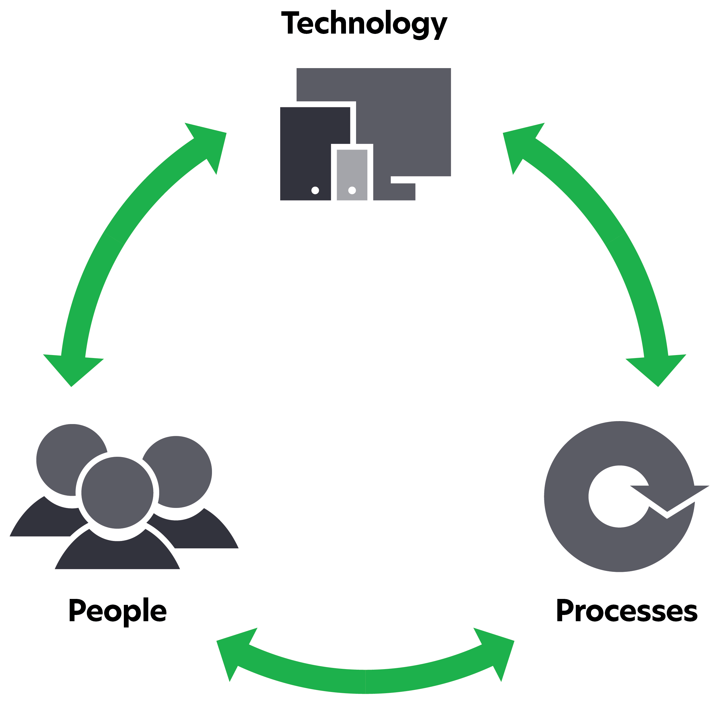
Our primary objective is to rightsize output devices with organizational requirements. Lexmark can help the Participating State or Entity achieve its goals of improving its business performance by better managing document processes with enabling technologies. Lexmark consultants have recommended and implemented solutions that contributed to significant reductions in print volumes and cost savings. Evaluating organizational output from a holistic perspective that considers all output processes (print on demand, central reproduction print, distributed print, copy, fax, and the like) is critical to devising solutions and implementing best practices that produce the greatest organizational benefit.

Lexmark works with enterprises to establish an understanding of their output environment. Lexmark has successfully engaged with hundreds of customers in developing output strategies that focus on the following:
- Device infrastructure optimization
- Supply chain improvements (streamline purchases and billing)
- Work flow improvements (document processes)
- Ongoing management and support
- Output cost reductions

Building on these efforts, Lexmark applies proven methodologies and processes to document a business’ current environment and clearly identify and prioritize the most significant opportunities for productivity improvements, effective use of technology and cost savings. By understanding the organization’s operational structure, IT strategy and organization’s objectives, we can apply Lexmark’s approach and processes and demonstrate why Lexmark is uniquely qualified to help meet short- and long-term strategic initiatives.

It is important to note that there are inherent differences to Lexmark’s approach versus our competitors’.
- Lexmark takes a more holistic view—improving the print infrastructure, moving (paper) information faster (electronically) and managing cost from the infrastructure. Lexmark goes beyond rightsizing the Participating State or Entity’s existing infrastructure and adds greater value to the management of this space.
- Lexmark’s focus to infrastructure optimization is on end-user productivity as opposed to device productivity.
- We see the value of MFDs to facilitate workflow and process improvement as opposed to simple consolidation of devices (although that is an inherent benefit).
- We look to optimize the utilization of the output devices, including existing devices where appropriate and to reduce the amount of pages produced to lower costs through Lexmark’s technology-based services rather than driving pages to centralized devices.
- Because of the sheer dynamics of this environment, the approach of copier companies to rightsize an asset infrastructure is typically too drastic and centralized. Too drastic of a consolidation can impact end-user productivity, employee morale and the overall current culture, ultimately resulting in higher overall costs for the organization. The typical results are a proliferation of personal devices in the user community.

Assessment scope

An effective assessment is one that drives the targeted savings. Lexmark’s proven assessment methodology begins with establishing a baseline of the Participating State or Entity current output infrastructure and the total cost of ownership associated with the current output services through an in-depth Discovery Office Print Assessment (OPA) focusing on device optimization within a representative subset of the enterprise. Lexmark will perform the output assessment of the Participating State or Entity’s current environment in two phases.

Phase I

During Phase I, Lexmark will work with the Participating State or Entity to select representative sample locations as the scope of facilities for a thorough due diligence of the current-state output infrastructure. Following a project planning activity period, the assessment is kicked off at the customer site with a meeting of both the Lexmark consulting team assigned to the assessment and the client sponsor and appropriate client employees to set all assessment objectives, schedules, contacts, deliverables, and other expectations.

Working with the Participating State or Entity staff, a team of Lexmark consultants will employ our proven methodologies, processes, and various analytical tools to gather detailed data on the current output volumes being produced and the current-state inventory. The device level data collected in the physical inventory is augmented by information gathered from key client employees during interview meetings conducted by the Lexmark consultants to understand the current acquisition, deployment, maintenance, and support processes used at the Participating State or Entity. Detailed information such as maintenance and service agreements, fax telephone line and toll costs, and other allocated charge rates (such as square footage charge rates, help desk, and other office print-related support) will also be utilized to create a Participating State or Entity–specific recommendation and business case. If actual or reliable data is not readily available, various estimation methods might be used to derive the needed information to complete the assessment. However, the idea is to obtain data from appropriate the Participating State or Entity organizations and devices in order to develop an architecture recommendation specific to the Participating State or Entity.

With the on-site data collection phase complete, the consultants perform a thorough analysis of the data collected, including the information gathered during the user interviews. The output of this analysis process is a complete description of the output environment, from device inventory to cost and performance analysis. Lexmark will also develop a baseline of the Participating State or Entity’s total cost of print (TCOP) specific to their current-state environment and actionable recommendations for improvement. The cost elements incorporated into the TCOP include acquisition/lease costs, consumables (ink, toner) cost, other supplies (maintenance kits, drums, and the like) costs, internal IT help desk / support costs, training costs, service costs, fax telephone line and toll costs, procurement costs and the like.

The findings are reviewed and validated with the Participating State or Entity management team to ensure that Lexmark has accurately captured the environment and where assumptions are made relative to costs or other data elements, that the client team agrees with the assumptions and supports the way in which they were used in the analysis. This validation meeting is crucial for the assessment process because it establishes agreement that the fundamental baseline is accepted and that any assumptions or calculations are supported by the Participating State or Entity team. The resulting baseline is then used as the current state to which a future-state design can be compared and contrasted to show the improvement opportunities, costs and impacts of future-state recommendations for change to the Participating State or Entity environment.

Lexmark will develop a set of metrics and deployment principles by functional area. These will provide the blueprints for future-state design moving forward.

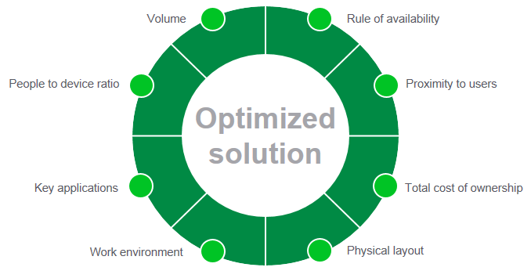

Upon completion of the data collection phase, the consultants will analyze the data collected, including the information gathered during the user interviews. Lexmark’s assessment methodology considers a number of critical factors, as represented in the diagram, to ensure that the Participating State or Entity achieves a fully optimized solution. This methodology gives consideration to a number of other factors which our experience has shown can greatly impact cost saving objectives, business productivity and end-user acceptance. These factors include the following:
- Peak period output requirements. Failure to consider peak periods may lead to the placement of an output asset that is fully capable of handling normal daily use but is undersized in terms of handling peak period output.
- Proximity to users. End-user needs, client-facing responsibilities and walking distance in terms of the facility where the end user works are also important factors to consider when architecting the output infrastructure.
- Total cost of ownership objectives. Maximizing cost savings on a cost-per-page basis could lead to a very aggressive device optimization strategy with a particular class of output technology but result in negative impacts to business productivity and end-user acceptance.
- Physical layout of the facility. The location of walls, workgroups within facilities, network drops and the like are critical to arriving at an optimal design.
- Work environment of the end users. For example, certain floors of a typical enterprise have staff from more than one department on the floor and each department separately funds the output devices supporting these staff. Device optimization opportunities may exist which would require end users from different work groups to share fewer overall assets. Thus, it is critical to understand the output requirements, such as peak periods, security requirements, output feature and functional requirements. Feature and function requirements can include the need for letter size, legal size, envelopes, color, mono, print, copy, and fax capabilities.
- Key system applications. Host or legacy applications and client-server applications may have unique print data streams and/or driver requirements that must be considered in the change management plan for migrating from current state to future state. Also, many organizations are working to implement electronic document management or content management systems in order to gain competitive advantages, improve customer service, and comply with regulations relative to output retention and security. The integration of these systems is driving the placement of MFDs with remote capture and business rules routing capabilities.

After an assessment of the current-state environment, Lexmark develops a set of governing principles and deployment principles that balance the design factors and create a best fit with the Participating State or Entity’s strategic direction and goals for the future output environment. The deployment principles become the decision guidance for selection and location of device types and device quantities that are placed in the future-state output environment.

In addition to the device type, quantity, features, location, and volume targets, the future-state recommendations may include support process changes, deployment exception process changes, opportunities for business process improvements, business case supporting the need for change, and other issues as desired by the Participating State or Entity and scoped in the original objectives for the assessment.

The final deliverable to the Participating State or Entity is a full presentation of both the current state and the recommended future state, detailing the findings, assumptions, and reasoning behind the recommendations.

Phase II

During Phase II of the assessment, the Lexmark team will work on a rapid, mutually agreeable schedule with the Participating State or Entity to perform site assessments or surveys at all remaining in-scope the Participating State or Entity facilities. The Lexmark team will evaluate each of these facilities against the deployment principles agreed to and developed in Phase I and develop future-state recommendations by floor for each in scope facility across all the Participating State or Entity sites. This site survey assessment approach is the springboard for operational changes to the current output infrastructure and enables the Participating State or Entity to quickly apply approved deployment principles to all facilities across the enterprise in order to achieve cost savings objectives. The Lexmark team will provide the Participating State or Entity project team with a set of transaction documents for each facility by floor that will include a current-state inventory of all devices with associated volumes, map current-state location of devices and a proposed future state, detailing device recommendations and locations.

Typical Office Print Assessment deliverables

For Phase I, Lexmark will develop and deliver a findings presentation which typically includes the following:
- Executive summary
- Overview of current state including maps, inventory, and costing
- Issues with the current state
- Recommendations for a future state, including maps, inventory, and savings
- Benchmark comparisons
- Business case
- Benefits
- Conclusions

For Phase II, Lexmark will develop and deliver an approval document for each facility which typically includes:
- Summary of program objectives
- Current-state and future-state mapping (where applicable)
- Current-state and future-state inventories
- Business case
- Disposal listing

- Describe how you calculate realistic cost savings for implementation of MPS.

Lexmark will work with the Participating State or Entity to establish a baseline current-state and future-state cost structure through its assessment services. This baseline cost analysis will include such factors as output device hardware lease, and replacement costs, telecom/fax costs, toner/consumables costs, maintenance costs, and paper costs.

Lexmark typically finds accelerated cost savings opportunities as organizations support going beyond device and vendor consolidation. In the state and local government agencies, customers typically save 22%–27% by moving to an optimized environment with Lexmark MPS.

Once the new fleet is in steady state, Lexmark consultants will be able to track and monitor cost savings. The basis of this cost analysis will be the current-state assessment performed in Phase I of the OPA. Lexmark will do its best to include all hard cost in its analysis. Lexmark will rely on the Participating State or Entity to provide all costs pertinent to this project.

The following elements will be analyzed to calculate the current total output cost:
- Current devices amortization period
- Acquisition cost for devices that are not fully amortized
- Current devices date of acquisition
- Current devices lease term (duration and cost)
- Current devices service/maintenance cost
- Estimated mono/color split on color devices (when data is not available on the device)
- Current-state fleet parts cost
- Average job size (pages)
- Number of hours in workday
- Workday days per month
- Energy cost (kWh rate)
- Average cost of one ream of letter-size paper
- Current length of warranty per device
- Monthly cost of a fax line
- Monthly maintenance/support cost of a network drop
- Duplex (double-sided) printing current policy
- Supplies cost
- Average annual volume per device

Based on this information, Lexmark will elaborate a current annual cost model for the Participating State or Entity and will present this model to the Participating State or Entity for validation.

- Describe your organization’s implementation strategy. The strategy should contain your approach to training, communication plans, and how continuous improvement and program management are collaboratively addressed.

Lexmark’s approach is consistent region by region, country by country, for all our MPS engagements and implementations. We operate a standard practices framework that is task-focused and ensures any project in one country is repeatable in another. This structure defines a logical methodology that can be supported by recognized project management approaches.

Schedule and approach
Implementation timeline
Following is a typical implementation timeline. This will be refined as we enter into the planning phase of the project.

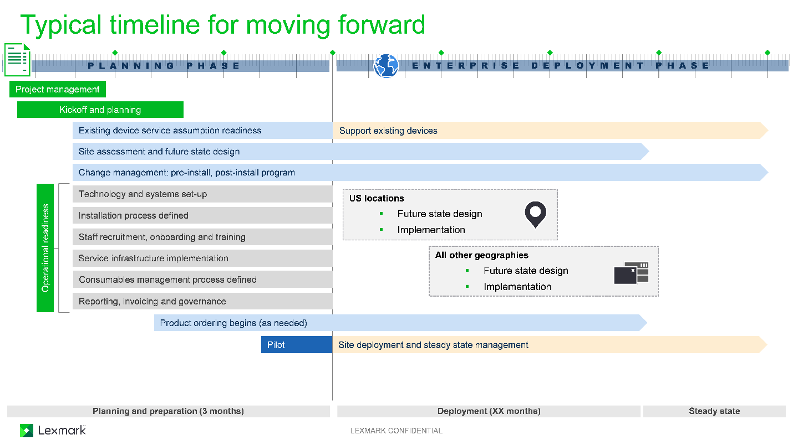

Planning phase

Upon contract signature, Lexmark will assign a project manager and an executive sponsor, and immediately begin the planning phase. This is a crucial time for the Participating State or Entity to also assign an executive sponsor. This person will be key in the endorsement of the program within the Participating State or Entity community. The Lexmark project manager will schedule a program launch meeting with the Participating State or Entity and work with key stakeholders to develop a project plan. Additionally, we will begin implementing our systems, tools, and key processes related to the implementation and steady state, which will be the core components of the program.

Change management and impact to client community

Another key piece of the planning phase is to immediately engage in change management planning. This process begins with an hour-long change management kickoff meeting with the key the Participating State or Entity stakeholders to include the project manager, project sponsor/management, corporate communications, and Lexmark project manager. The objective of this meeting is to establish a high-level change management plan that encompasses the goals, approach, roles of the Participating State or Entity and Lexmark, and the tactical next steps that have to take place for an effective transition. The second step in this process is to conduct a change management workshop that is typically two to four hours long where we dive into the details of next steps that will need to be executed. Additionally, we suggest periodic (typically once a week) change management calls with the project managers during the initial transition phase of the project to discuss the status of all the change management actions, follow-ups needed and other related matters.

The impact to the end users can be kept to a minimum provided the necessary change management communication has been successfully distributed to and received by the end users. A typical device installation takes 30 minutes to an hour, with 15 to 30 minutes of end-user training that immediately follows the installation. We have found that when the end users have been made aware of the schedule for their device installation, they can plan appropriately and thereby minimize the impact to their office or department. Additionally, communicating the schedule in advance allows for feedback in the event a particular date and time is not suitable for the affected office.

Deployment phase: Pilot

The deployment phase begins with conducting a pilot at three to four sites over approximately two weeks. At a minimum, Lexmark recommends a pilot for one field location and one back-office location. During this time, it is important to note the differences between different types of field locations. The pilot will help Lexmark and the Participating State or Entity validate the processes established in the planning phase. Some examples of those processes are described here:
- Communication plan: Implement a change management and communication strategy to get the program started on the right track. This helps users understand the purpose of the program, the benefits to the Participating State or Entity, what processes could change and what that means to the user.
- Order/delivery process: Document how the order flows through Lexmark and the logistics of how the devices will be delivered to the sites.
- Install instructions: Document the steps for the technician to follow at the site to complete the install, train the end users, and gather important device information to share with the Lexmark PM to make sure our systems are updated appropriately for asset management, billing, and warranty entitlement purposes.
- Training plan: Create a training plan as well as training materials for end-user training during implementation, as well as leave behind training materials and training videos for additional reference. Many of our customers choose to post these training materials to their internal web sites for users to access as needed.
- Removal process: Covers de-installation and set aside of the existing equipment.

After the pilot, Lexmark and the Participating State or Entity will jointly document the key lessons learned. We will compile input from the Participating State or Entity, then the Participating State or Entity and Lexmark will discuss what went right and what went wrong with the pilot to determine if we need to make small tweaks to the project plan and process documents before rolling out to the enterprise.

Deployment phase: Rollout

The next steps following planning and piloting involve the roll-out to the enterprise using repeatable processes that were tested and refined using lessons learned from the pilot install. During the planning phase, Lexmark will work with the Participating State or Entity to determine actual deployment days and the path of deployment. We can deploy five days per week, seven days per week, or during evenings and weekends. Lexmark has also found success in deploying four days per week and allowing a 5th day for cleanup/buffer. Regarding the path, some of our customers choose to deploy back-office and field locations separately. Some regional customers choose to proceed one state at a time. Some customers prefer to install the largest sites first in order to accelerate the cost savings. This will be a collaborative process and Lexmark will incorporate the Participating State or Entity’s specific needs into the scheduling.

Resource requirements

Outline of transition roles and responsibilities

One of the key elements for successful transition to Managed Print Service is the allocation of specific roles during the assessment, implementation phases, and during the day-to-day execution of the contract. The following provides an overview of the key roles for both the Participating State or Entity and Lexmark. These play an important part in ensuring the effectiveness of the relationship and resulting improvement in communication and management.

Detailed description of transition roles and responsibilities

The following information provides more details on customer roles that we typically find in our engagements and expect could occur with the Participating State or Entity project. The primary roles from the Participating State or Entity will be the assignment of an overall program manager and project manager. The rest of the transition and ongoing management team from the Participating State or Entity and Lexmark could overlap the different tower leads described here. In other words, there may be one individual that serves multiple roles and towers within the transition and steady state management. Lexmark proposes a transition and steady state management team that will consist of the following:
- Executive sponsor: Lexmark and the Participating State or Entity will assign an executive sponsor to monitor the progress of the overall program on a quarterly basis.
- Program manager: Lexmark recommends that the Participating State or Entity assign a program manager to provide oversight of the program, with the authority to take actions on either party’s behalf.
- Tower leads: In order to manage through the transition period, Lexmark recommends that both parties assign “tower leads” to implement the program during the transition period. Tower leads may be responsible for more than one tower function. The following tower leads are recommended:
  - Transition management: Both the Participating State or Entity and Lexmark should assign project managers for 12 months to manage the implementation of the program. The Lexmark project manager will be responsible for creating, updating, and managing the overall project plan for the program. Each project manager will coordinate all resources for each respective organization.
  - Device optimization/assessment: Lexmark will assign a consultant for the first year to lead the optimization efforts. In addition, business consultants and other Lexmark resources will be assigned to collect electronic and/or on-site data from each the Participating State or Entity Location and create a future-state design. the Participating State or Entity, through its transition/project manager, will contact each location scheduled for an on-site visit to coordinate resources for data collection and all sites for future-state approval.
  - Deployment: Lexmark will assign a lead project manager and project coordinator each for the deployments. Lexmark recommends that the Participating State or Entity assign a project manager for the deployments who will coordinate with the Participating State or Entity’s locations for the installation of hardware.
  - Tools and technology: Lexmark will assign a technical program manager and solutions development software engineer for the implementation of our print release solution, and systems engineer to implement the infrastructure required to support the Participating State or Entity environment. Lexmark recommends that the Participating State or Entity assign a resource to assist the implementation within the Participating State or Entity environment.
  - Asset procurement: Lexmark will assign a project coordinator to implement and execute the asset procurement process based on the deployment project plan. Lexmark recommends that the Participating State or Entity assign a resource to assist with the implementation of the asset procurement process including any testing, certification, and internal asset processes within the Participating State or Entity.
  - Asset management: Lexmark will assign a COM to implement the infrastructure required to support the Participating State or Entity environment. Lexmark will coordinate the designated install, move, add, change (IMAC) activities, and our business operations specialist will manage the Participating State or Entity’s asset database to ensure accuracy. Lexmark recommends that the Participating State or Entity assign a resource to assist with the implementation of asset management within the Participating State or Entity environment.
  - Device monitoring: Lexmark will assign a technical operations engineer to implement the device monitoring infrastructure required to support the Participating State or Entity environment. The Lexmark site operations specialists will utilize the monitoring tools to proactively monitor and maintain the assets under management. Lexmark recommends that the Participating State or Entity assign a resource to assist the implementation of device monitoring within the Participating State or Entity environment.
  - Consumables management: Lexmark will assign a COM to implement the infrastructure required to support the Participating State or Entity environment. Lexmark recommends that the Participating State or Entity assign a resource to assist the implementation of consumables management including such elements as building access within the Participating State or Entity environment.
  - Hardware break-fix: Lexmark will assign a COM to implement the processes and infrastructure required to support the Participating State or Entity environment. Lexmark recommends that the Participating State or Entity assign a resource to assist the implementation of these processes within the Participating State or Entity environment.
  - Service management and reporting: Lexmark will assign a COM to implement the services management and reporting processes required to support the Participating State or Entity. Lexmark will also assign service key account resources to monitor all service calls to closure and proactively escalate any calls outside of our service level objectives (SLO). Lexmark recommends that the Participating State or Entity assign a resource to assist with the review of these processes during the implementation within the Participating State or Entity environment.
  - Firmware, security updates and print queue coordination: Lexmark will assign a systems engineer to assist with the identification of processes and infrastructure required to support the firmware, security updates and print queue coordination in the Participating State or Entity environment. Lexmark recommends that the Participating State or Entity assign a resource to assist the implementation within the Participating State or Entity environment.
  - Change management: Lexmark will assign a principal consultant to lead the change management and communication plans throughout the Participating State or Entity during the 12-month implementation. Lexmark recommends that the Participating State or Entity assign a resource to coordinate change management activities within the Participating State or Entity environment.
  - End-user training: The Lexmark project manager will ensure that end-user training takes place at the time of device installation. the Participating State or Entity will need to ensure that all appropriate employees will attend and actively participate in the training.
- Steady state management: Lexmark will assign a services program manager, COM, operations specialist, service key account resources, and the back-office business operations resources necessary to manage the day-to-day ongoing operational items for all components implemented during the transition phase. The services program manager will own all operational responsibilities and customer satisfaction metrics for the Participating State or Entity. The Lexmark COM and operations specialist will manage the governance process and conduct daily/weekly, monthly, quarterly, and annual reviews. Lexmark recommends that the Participating State or Entity assign a steady state resource to communicate day to day issues and coordinate other the Participating State or Entity resources to resolve issues as needed.

- Describe your training approach to ensure that customers are well versed in how to maximize your Managed Print Services approach. Offerors should include the types of training available (targeted, web-based, on-site, one-on-one etc.) in their response.

Lexmark has a proven training methodology that will be used to provide the most effective customized training program to meet the specific needs of the Participating State or Entity. Depending on the customer’s requirements, we can provide any of the training options requested above, some of which may incur additional fees as described in our pricing template. We typically provide a 15-minute end-user training for each device type that is implemented in each of the locations. These sessions are designed to occur at the time the equipment is installed.

Some key elements of training may include (but are not limited to) the following:
- A mutually agreeable method, schedule, and training topic(s) will be determined by the Statement of Work (SOW)
- Training sessions scheduled and communicated in advance for each location
- Site trainers following behind equipment installers
- Trainings delivered at the device locations in group settings
- Q&A to address attendees’ specific needs

Typical duration: 15–30 minutes per session (5–10 staff members per session)
Example agenda:
- Consumables replacement
- Proper paper-loading procedures
- Clearing paper jams
- Basic Copy functions, where applicable
- Basic Fax functions, where applicable
- Scanning to destination, where applicable, such as Scan to E-mail, Scan to Folder, etc.
- Specialty media printing (i.e., envelopes, labels, letterheads, etc.)
- Finisher functions, where applicable
- Basic Driver functions, such as duplex, n-up printing, print-and-hold features, color/mono printing, etc.
- Q&A

Training material provided to end users electronically:
- User Guides
- Quick Reference Guides, as required
- Online training videos

Customer responsibilities:
- Approve training schedule, topics, and methodology
- Assistance with communication and scheduling of participants
- Access to a user workstation for printer driver training (optional)

Additional training options are also available, some of which may require additional charges depending on the scope.

- How does your organization remain competitive in the managed print industry to improve efficiencies? How do those efficiencies transfer to your customers?

Changes/expansion of MPS strategy over the past year

Over the past year, Lexmark has continued to focus on several key areas including expansion of infrastructure management, cloud-enabled services, print as a service, mobile capture, and print, sustainability, and analytics. The core of our MPS infrastructure is owning our own technology, which affords us to remain competitive in serval areas.
- Owning our own technology and software allows Lexmark to react to customer needs in very effective and efficient manner. The use of Predictive Services, as described in the following paragraphs and item 3.g. of the Scope of Work Response Part II (Attachment F), enable Lexmark to react and detect issues prior to device failure, which in turn provides a cost-effective management of the fleet. Since we own our technology, we have embedded these predictive sensors into our devices, which provide more information on the fleet. Software such as Lexmark Print Management (LPM), as described in the following paragraphs, is another software owned by Lexmark. This development has eliminated the use of third-party software, which can cause inflated costing and pricing that is ultimately cost prohibitive. Ultimately, Lexmark has a proven track record of reducing print and improving efficiencies, and as result we have a 95% renewal rate on our current contracts. These efficiencies as well as the current and future developments will keep Lexmark competitive in the managed print service industry for years to come. See Section 6: Supplemental Documents for end user license agreements.
- Infrastructure management is an emerging offering based on increasing demand for a customer’s MPS provider to provide the print management infrastructure including the provision, setup, and ongoing management of a Print Release solution. This can be provided on the customer’s premise or via a cloud-based offering. Lexmark has provided this full service to a variety of clients using our own software (LPM). When applicable, Lexmark has a variety of partners, including Nuance and LRS, which also includes responsibility for print servers and print queue management.
- Cloud-enabled services allow Lexmark to further enhance and broaden the way in which we deliver our portfolio of services and solutions. Cloud-based services have been a component of Lexmark’s offering portfolio for some time. Specific to MPS, Lexmark’s offerings are built upon internet/cloud technologies that enable remote management of output devices anywhere in the world. Lexmark’s fleet and configuration management service uses tools that may be leveraged inside or outside a customer’s physical network.
- Print as a service is a customer need that Lexmark has responded to by making meaningful enhancements to our already flexible and fully customizable offer to support the modern workplace and employee. With the release of the Lexmark cloud platform, we are positioned to provide the complete print infrastructure, not just the print devices. And we are deploying devices owned by Lexmark, removing the balance sheet impact in favor of a subscription-based agreement for print.
- Mobile Capture and Print is a critical capability required to support multiple end-user scenarios. Lexmark’s mobile print solution allows documents to be securely sent via a company’s secure e-mail infrastructure to enable employees to print on the go from any e-mail enabled smartphone and tablet. Lexmark’s mobile printing solution via the Lexmark Print Manager provides unique features: (a) one mobile app that provides both direct printing at home and also printing via print release while in the office; (b) a mobile app that provides direct printing and supports business networks (not limited to local Wi-Fi only); (c) a hosted, Software as a Service (Saas) deployment option for enterprise mobile printing; and (d) the ability to provide a unified view of print usage for mobile and desktop printing. Incorporating this robust mobile print capability into our MPS engagements allows Lexmark to meet the output needs of customers with unequalled flexibility in features and implementation options. See Section 6: Supplemental Documentation to review end user license agreements for Apple and Android mobile apps.
- Sustainability is a long-standing commitment Lexmark has made to reduce the consumption of natural resources worldwide. As a result of this commitment and the actions we have taken, we have received numerous awards in the area of sustainability. Lexmark is focused on all aspects of the product life cycle and in reducing the environmental impact in each area and at each stage, such as reducing energy consumption, water consumption, size and weight of devices and components, high yield cartridges, long-life components, reducing service interventions, recycling, and other areas.
- Analytics is the value derived from utilizing data associated with our many MPS engagements. Lexmark long ago established repositories where data from assessments, device usage, and other MPS operations activities could be brought together, mined, and analyzed. Today, Lexmark is making significant investments in the use of analytics to optimize the output environments for our MPS customers as well as improve device availability and streamline business processes. Lexmark’s extensive capabilities in the area of enterprise content manager (ECM) provide another rich source of data to make even broader the amount and type of data Lexmark can draw from. This allows for even deeper analysis of the customer environment and results in the identification of new and leading-edge industry-specific workflow and business process optimization services.
- Intelligent capture continues to show increased interest and acceptance with larger enterprises that want to streamline processes and improve operations. Lexmark Intelligent Capture allows for accurate sorting of paper and electronic documents based on their content, lifts critical information based on its context, validates it, and seamlessly passes it to core business applications. The underlying proprietary technology abandons traditional template-and-rules-based approaches to data capture in favor of advanced pattern-recognition techniques that work like the human mind. So instead of mapping fields and defining key words for every document format, Intelligent Capture learns from a small sample set and then processes widely diverse document layouts. Invoice data is automatically streamed into financial management systems, remittance detail is available for cash application, personnel content flows into an enterprise planning resource (ERP) system, and so forth—instantly, with no opportunity for human error. Intelligent Capture eliminates volumes of exceptions, errors, and manual rework through its intelligence to learn documents of all types like the human brain. Integration is possible with virtually any ERP, ECM, data management (DMS), departmental, and business system allowing it to be up and running quickly, handling different document and file types, in different languages, across different departments. This allows real-time insight and analysis into capture processing and allows customers to gain immediate access to metrics and KPIs as well as detailed views of key processing steps. Lexmark is the market leader in this area.

Lexmark’s significant investments in MPS for 2017 and 2018

Lexmark continues to make significant investments in capabilities to support direct and indirect MPS sales. Recent investments include the areas of MPS Process Analytics and Predictive Service to expand the cloud platform enhancements Lexmark offers to our customers. Additional investments by Lexmark include a hardware refresh which will cover over 90% of the fleet and be completed by the end of 2018 worldwide.

Lexmark MPS Process Analytics advances the process of customer print document management by first evaluating and then developing a roadmap with a step by step process to print document management maturity. Lexmark uses a comprehensive data set with over 150 different metrics, collected by our robust data mining tools, evaluated by data scientists, and guided with years of industry expertise to development each analysis roadmap. Customers using MPS Process Analytic services pinpoint and resolve document management roadblocks, cut unnecessary cost, and reduce risk from paper-based processes.
- Predictive Service Alerts—In 2018, Lexmark began a program for select channel partners to leverage our predictive analytics capabilities. This offer centers on Lexmark’s ability to pass system generated predictive alerts to the partner via e-mail or through an API integration, as our existing enterprise systems detect device needs. Partners then have the context and insight needed to take preemptive action to remotely restore the device or reach out to the customer and dispatch service. Participating partners enjoy reduced service costs, fewer skilled service personnel dispatches, and improved customer experience.
- The Lexmark Cloud Platform—Launched in 2017, it was initially comprised of LPM and the introduction of device management. This platform is expanding in 2018 with additional remote device management capabilities for customers and partners. This will allow customers to easily manage the devices in their own fleet. Partners will also be able to provision customer instances to enroll and manage Lexmark devices, simplify device setup with preconfigured applications and automatically deploy preconfigured device bundles and firmware. This will enable a partner to provide a more proactive approach to device management, saving travel time and associated costs as well as improving the customer experience.
- In 2018, Lexmark has done a complete refresh in its technology portfolio, giving Lexmark a completely cohesive product line up that gives customers the ability to truly implement a standardized print infrastructure without sacrificing the flexibility they need in placing the right device in the right location. The new portfolio features attributes that will help customers simplify device management, enable user productivity, and extend their technology investment. Notably, our portfolio, from small workgroup all the way up to large departmental devices, shares common firmware and a common operating system which simplifies device management, implementing security updates, and supporting mobile users.
  - A common user experience across the portfolio allows users to easily leverage productivity tools that help expedite document tasks. Moving between devices is easier than ever as the device menus and visual cues are consistent across the range.
  - Lexmark has bolstered the reliability of these devices with industrial metal frames that eliminate vibration and skew and allow the devices able to withstand harsh environments. Advanced sensors within the devices inform algorithms that enable highly accurate estimates of available pages before replacing toner, and detailed diagnostics when service is required.
  - Also, all devices have long-life components including, for example, a 400K aftermarket imaging unit on large workgroup devices which could be considered a lifetime component. And aftermarket toner yield of up to 55K on our high-end A4 workgroup devices rival’s capacity on A3 devices and far surpasses what is available on competitive A4 models.
  - Easy security updates over time, and a consistently secure portfolio of devices are enabled by our new standardized firmware and operation system across the entire portfolio. Regardless of which device is place into the customer environment, the same security standards are in place.
  - Advances in ease of use, reliability and durability enable customers to keep Lexmark devices safely installed well beyond the typical 5-year life, eliminating churn for both users and IT. In addition, our complete new line up is Blue Angel certified.

All these services, current and in the future, have positioned Lexmark on the leading edge of MPS and have translated it to our customers by providing a cost-effective and efficient print environment.

- What type of reporting is available to customers? Are customers able to access these reports themselves?

Lexmark’s significant investment in the MPS infrastructure means that near-real-time updates to key standard reports are available 24/7 to the Participating State or Entity team.

At the core of a Lexmark services engagement is the ability to capture information on individual assets. Lexmark’s MPS offering relies on the Lexmark Data Collection Manager (LDCM) to provide this functionality. The LDCM is Lexmark’s hardware and software solution that is to reside within the Participating State or Entity’s network environment. This provides a secure and automated way to collect asset information, transmit the information back to Lexmark and take action on assets. The timely information provided by the LDCM is joined with information in the Lexmark Asset Relationship Management System (ARMS) to provide a complete picture of the Participating State or Entity’s output environment. This allows Lexmark to partner with the Participating State or Entity to drive lower costs and higher productivity in document technologies and output solutions.

The LDCM is a key technology component that increases the efficiency of Lexmark’s MPS services business. This technology coupled with Lexmark’s proven business processes/methodologies and experienced resources will help you tap into one of the last opportunities for sustained operational cost savings. MPS will help you print less, move information faster and better manage output across your organization.

Available standard reports

Lexmark has the capability to generate a wide variety of standard reports and invoicing formats. We will work with your company to generate customized reports based on your specific needs. As part of our standard reporting package, we can generate reports that clearly define print-related costs on both a summary level and a printer level. We can also generate asset management reports to ensure proper utilization and compliance with any output device policies developed by the Participating State or Entity.

The Lexmark Managed Services Portal provides a complete view of departments/agencies under MPS engagement. The information you need can be accessed with few simple clicks. This new portal offers a personalized, convenient, and intuitive experience:
- Improved usability—quickly complete transactions and run reports with simple clicks
- Document sharing on the portal allows for the sharing of useful information such as custom reports, training materials and contractual documents—putting all relevant information about your output fleet at your fingertips
- Technical architecture is built for 24/7 availability and fast performance
- Visibility is adjustable by role and/or locale—choose to view a little, view a lot or view your entire operation
- Robust reporting interface provides accurate and instant status on all requests
- Customer IT administrators and staff can make requests and check status
- Mobile friendly for on the go access

All presented information will be available to the Participating State or Entity and its clients via the Managed Services Portal—Document Library. In addition, our standard reports are available 24/7 for our clients to access. They are available in several formats including PDF, HTML and CSV.

Lexmark’s Managed Services Portal provides eight standard reports that are available to all portal users. A customer can run these reports at any time and export the detailed results. Reports with an asterisk (*) include additional dashboard chart preview with hover details.
- Asset Register: Provides current line by line detail for all Managed Output Devices actively registered in the asset database under a customer agreement. The report includes current detail for each device, by serial number, including location, customer asset tag, model type, IP address, hostname, lifetime page counts, cost center, accepted status, install date, term start and end dates, and more. There are no prompts or customizable parameters for this report: The Asset Register report runs immediately when selected by the customer.
- Device Changes (MADC)*: Provides detail of all occurrences that caused a change to the customer’s fleet including Moves, Adds, Decommissions, Changes, and Swaps, over a selected date range. The report details include information about changes to a device’s network identifiers, asset tag, location, and more, and is sortable by even type and/or date. The user may select to filter by MADC event type, and/or date range when running this report.
- Missing Meter Reads*: Shows devices that have not reported a page count meter read to Lexmark in ‘X’ number of days. The user can select to filter by meter type (automated, manual, or all) and by the number of days a device has not reported (the default is 60 days).
- Consumables Orders*: Provides detail of all consumables supplies orders recorded for a selected date range, whether manually placed or automated. Details include order creation, shipment, and delivery dates, status, device model and detail, part number, description, tracking number, location, quantity, order type, etc. The user can select to filter by date range when running this report.
- Hardware Orders*: Provides detail of all hardware orders recorded for a selected date range. Details include order creation, shipment, and delivery dates, status, hardware model number and detail, part number, description, tracking number, location, quantity, type, etc. The user can select to filter by date range when running this report.
- Pages Billed*: Provides line by line detail of pages billed, by device serial number, for the selected date range.
- Hardware Installation Requests*: Provides details for all hardware installation requests and the details associated with the installs. The output includes order creation, shipment, and delivery date, location, contact, quantity, type, model, order numbers, purchase order number, shipping method, product description, customer reference number, etc. The user can select to filter by date range when running this report.
- Service Detail Report: Provides line by line detail for break/fix service requests and actions, by asset, for a selected date range. The output includes request creation and completion date, status, parts shipped, device type and details, location, service summary, cost center, and more. The user can select to filter by date range when running this report.

Key Performance Indicators

In addition to the 8 standard reports, the Managed Services Portal provides three at-a-glance Key Performance Indicator (KPI) visualizations:
- Fleet Availability: Shows the percentage of the total fleet that was operational, or “up”, versus the total number of potential operational hours for the last full month.
- Service Response Time: Shows the percentage of initial responses to service calls that were achieved within the time designated by the service level agreement (SLA) for the last full month.
- Supplies Shipments: Shows the overall percentage of service and/or supplies orders that were shipped within the contracted SLA for the last full month.

Governance Reports

Reports and analysis developed as part of our governance process may be posted in the Managed Services Portal for customer to access at any time. These reports include:
- Fleet Governance reports: Performance measurement, fleet analysis, and recommendations regarding fleet optimization, cost, and day-to-day operational activity.
- Business Governance reports: Sustainability reporting and Lexmark MPS Process Analytics to help identify business process inefficiencies and workflow improvement opportunities and recommendations.

Custom Reports

The Managed Services Portal provides for additional flexibility to allow additional customization as required.
- Custom filter views: In the Managed Services Portal user interface, the user has the ability to easily navigate and view devices, orders, and requests using filters, date parameters, bookmarks, etc. and can export any view to a clean flat excel format as desired.
- Additional custom reports: Should Lexmark and customer mutually agree to additional custom reports, they may be posted in the Managed Services Portal for customer to access at any time.

Project management

Additionally, Lexmark will appoint a COM who will own and coordinate the seamless end-to-end delivery of all the Lexmark services to the Participating State or Entity. The COM will have responsibility for the support and the delivery of agreed-to services, along with appropriate reporting. The COM will also ensure a high level of customer satisfaction for the entire engagement.

The COM assigned to the Participating State or Entity will report to the Lexmark and Participating State or Entity’s outsourcing team and Services Program Manager (SPM). The SPM is ultimately responsible for the delivery of all services to the Participating State or Entity and overall satisfaction.

As part of the overall service management plan, Lexmark will leverage the experiences and processes that are in place with other large customers like the Participating State or Entity. For example, the project office will monitor, measure, and report the performance against the contract requirements.

The project office will collect and report program, operational, and financial measurements, and report these to the executives in the Participating State or Entity and Lexmark.

The project office is responsible for executing the following administrative functions:
- Contract management
- Financial management of the account
- New requirements/proposal management
- Business measurement and reporting
- Overall governance and process documentation
- Business controls
- Quality assurance

- How frequently do you conduct customer business reviews and what do those reviews include?

Governance Process

Lexmark employs a two-tiered, global governance model to deliver value to our customers, reviewing Lexmark’s alignment with your organization’s strategic objectives, through quarterly and semiannual business reviews, as well as maintaining continuous touch points with customers through weekly and monthly review of tactical objectives.

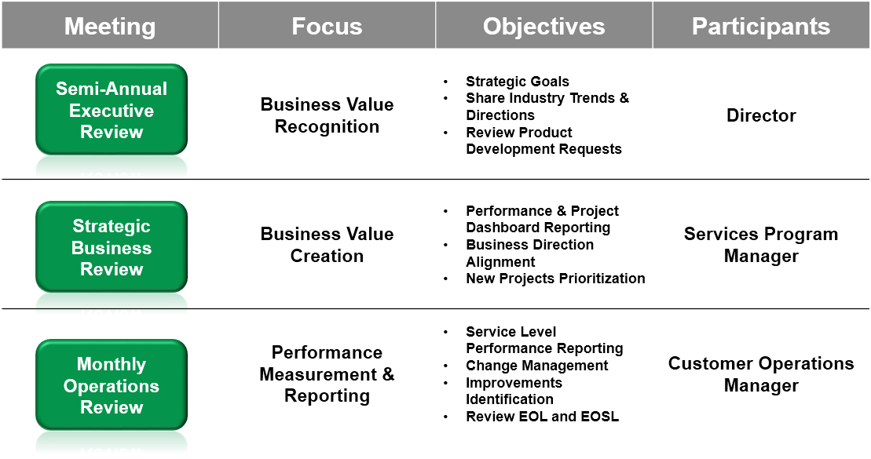

Weekly Reviews
Lexmark examines project operations and execution, reviewing delivery issues and resolution management. We do this alongside our customers on a weekly basis. Lexmark conducts weekly progress reviews during the transition phase to provide updates and status on our transition efforts. These meetings provide updates and status on our transition efforts including resource allocation reviews, progress and overall effectiveness, risk identification and mitigation recommendations to achieve the transition objectives.

Monthly Operations Review
On a monthly basis, we review our SLA reporting, task updates, root cause and business impact analysis. The Monthly Operations Review is focused on providing performance data for the fleet at the device and fleet levels. These monthly reviews report contract KPI as defined during our contracting process. The following graphic shows a typical KPI slide.

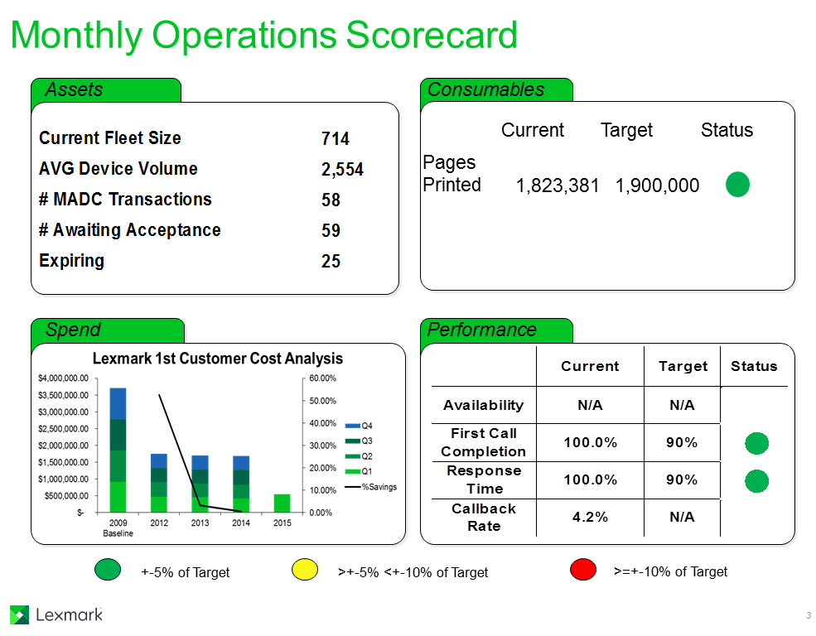

Strategic Business Review
On a strategic level, Lexmark reviews on a quarterly basis performance and project dashboard reports, business direction alignment and new projects prioritization. The Strategic Business Review is focused on fleet performance over the quarter in question and how this quarter compares to prior quarters. This review is also focused on Lexmark’s ability to manage the fleet to meet your business goals, whether that is further cost reduction or integration of the managed fleet with particular applications. Lexmark will present concrete proposals at each review that will forward these goals.

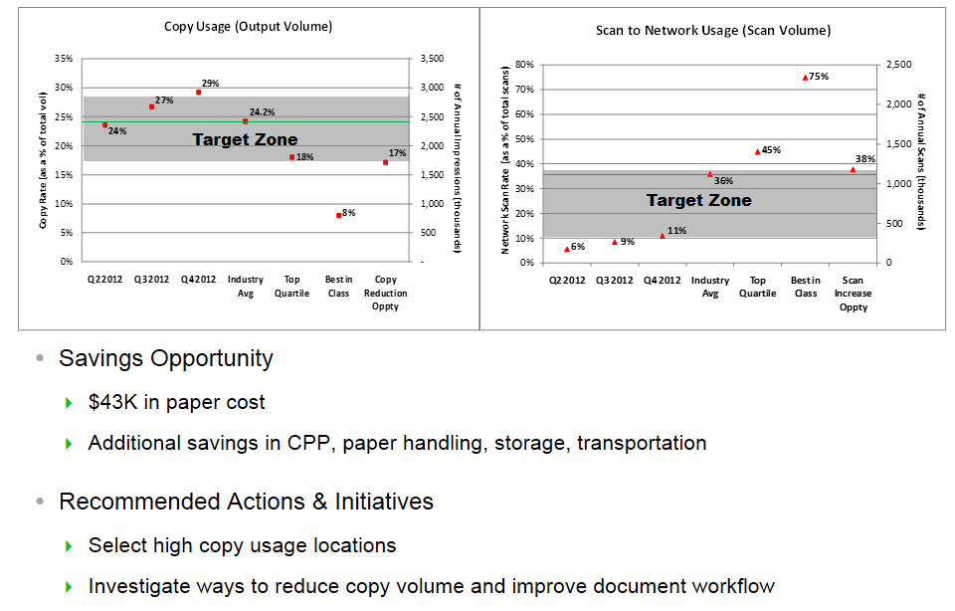

Semi Annual Executive Review
On a semiannual basis, we review Lexmark’s understanding of our customers’ strategic goals and their industry trend, and foster executive level relationships. This review is designed for a management audience and focuses on contract performance, strategy, and planning at both the operational and financial levels. It seeks to provide a forum where management can outline their business objectives, to be found in the bottom right quadrant of the following illustration, so that Lexmark can manage our deliverables to achieve these business targets. Customer satisfaction and innovation or continuous improvement objectives are reviewed for improvement opportunities.

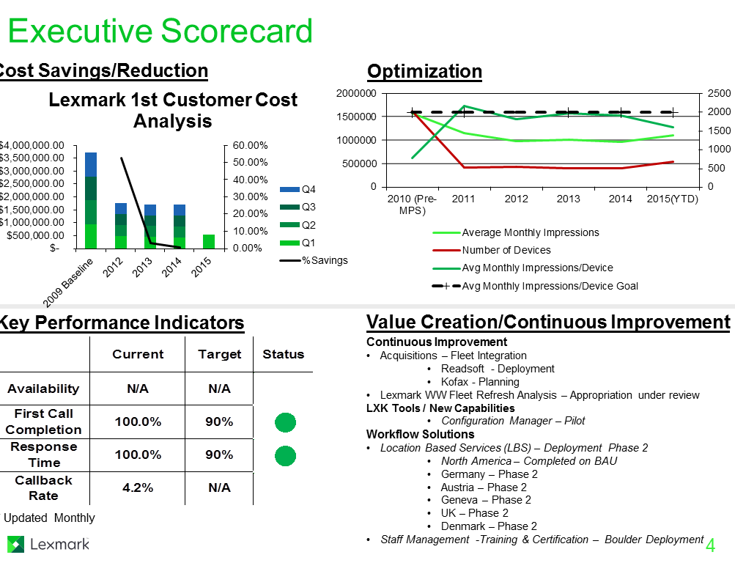

The Lexmark Managed Services Portal
All presented information will be available to the Participating State or Entity via the Lexmark web portal—Document Library. In addition, most of our standard reports are available 24/7 for our clients to access. They are available in several formats including PDF, HTML and CSV.
Overall satisfaction with our performance based upon compiled survey data is reviewed and improvement strategies are reviewed.

We will assess the Participating State or Entity’s satisfaction with Lexmark performance around four key areas:

Overall Satisfaction
- Performance evaluations of contracted services
- Responsiveness evaluations
- Resolution and guidance evaluations
Value
- Productivity Improvements
- Efficiency Improvements
- Cost Improvements
Relationship
- Business Interest Alignment
- Commitment to Success
- Renewal Intentions
- Recommendation Intentions
Loyalty
- Business Guidance
- Technology Leadership
- Process Innovation

Our objective through Lexmark’s governance process is to provide a closed-loop feedback process, working with our customers to map a customer action plan and commensurate Lexmark resource investment, review our collective process throughout the year, deliver value-added strategic recommendations for continuous improvement, measured, and backed up by an annual customer satisfaction survey, the results of which drive ongoing improvement in service delivery.

- What happens if a customer’s cost savings are lower than your projected cost savings?

Lexmark would work in partnership with the Participating State or Entity to determine appropriate targets and measures. We refer to this as building a long-term output strategy roadmap. Output strategy roadmaps are unique to every company. While industry benchmarks are useful for context, Lexmark will seek to establish targets and benchmarks that are appropriate for the Participating State or Entity. The goal of the strategy is to balance cost, user satisfaction, productivity, and corporate objectives. Output strategy roadmaps also establish watermarks for accountability. Strategic Business Reviews (SBRs) ensure that both Lexmark and the Participating State or Entity are tracking to the established objectives over the life of the contract. We believe this strategy delivers the lowest total cost of output for the organization and avoids cost shifting.

In some cases where projected cost savings are greater than what was expected, Lexmark and the customer have shared in those savings through collaboration as an addendum to the project agreements.
- Depends on pricing model
- Capture savings throughout the remaining years of the period of performance.

Many variables can contribute how these savings can be captured. Lexmark is willing to have a conversation if these were to occur.

- Provide two (2) detailed examples of your organizations experience in implementing and managing MPS for government entities. Include information such as the size of the fleet, the type of services provided, and the outcome of the project relative to the customer’s expectations.

Through our MPS program, Lexmark serves hundreds of customers with needs similar to the Participating State or Entity. We are a leader in providing direct MPS to large international companies, with some customers having more than ten thousand devices under Lexmark management.

Many Lexmark success stories are available at https://www.lexmark.com/en_us/success-stories.html, representing a variety of industries, company sizes, and Lexmark products, solutions, and services. Listening to and reading these references will provide you with examples of how Lexmark has helped other organizations achieve results.

We have many customer reference accounts that have implemented Lexmark solutions on the scale the Participating State or Entity is considering. If the Participating State or Entity would like to have a discussion with any of the attached references, we would be happy to facilitate such a conversation on your behalf.

As you might expect, Lexmark receives many reference requests. Responding to these requests is extremely important to us and yet, we have a responsibility and obligation to respect the time and confidentiality of our customers. To serve both our prospects and customers, we have a process to meet your requirements, while protecting our customers’ privacy and minimizing the impact on their valuable time.

Please refer to the appendix at the end of this section for more details on some of Lexmark’s MPS customers:
- New York City Human Resources Administration
- Washington State Department of Labor and Industries

Lexmark’s customer reference team can schedule a private call between your team and our current customers at a mutually convenient time. No one from Lexmark participates on these calls. We simply coordinate a date and time between the parties that is mutually convenient and make the initial introductions.

When you are ready to speak with Lexmark’s customer references, please contact Katie Lockett or Kristine McNutt, your Lexmark regional manager.
Katie Lockett
Customer Reference Manager
Imaging Solutions and Services
Lexmark International, Inc.
Office: 303-710-2937
E-mail: katie.lockett@lexmark.com

Upon award, we will work with the individual partner to provide more specific references for that geography and end-user opportunity.

VALUE ADDED RESPONSES:

- What is your experience with driving and communicating Change Management?

Communication planning

The communications or marketing plan is often used interchangeably with change management. However, when a communications plan is created in the absence of a structured change management approach, it ends up being a “telling” plan that simply informs employees about the progress of the project.

Lexmark assists with developing a communications plan as a part of our structured change management approach. The goal of the plan is to answer the questions that employees may have regarding the program and how it will impact them. Working jointly with the Participating State or Entity organization is very important to ensure that communication plan enables the Participating State or Entity to send the right message to the right audience at the right time and from the right sender and appropriate channel.

The process for developing a communication plan (following is a template example) involves identifying the impacted audience, gathering feedback or concerns from impacted audiences, selecting key messages and timing, determining content and delivery methods as well as the owner and sender of each message.

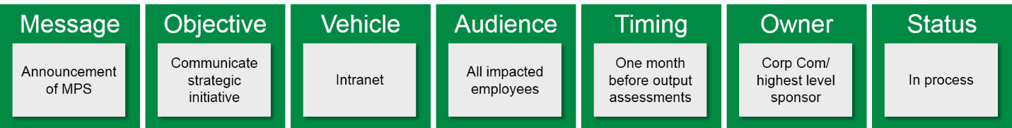

Communication package

The communication package will detail the steps that will be executed to guide employees through the change and provide the information necessary to be prepared for the process adoption that is expected of them. Based on the Participating State or Entity’s requirements, the communication package could include any or all of the following:
- Announcement of strategic initiative published by C-level executive to all employees
- Stakeholder and end-user communication documents
- Post corporate output guidelines
- Publish updates/feedback on implementations
- Publish implementation plan
- Publish processes for who to contact for help, issues, questions, and supplies
- Host output/solution demonstration days
- Post quick reference guides and tips at devices

There are many venues that can be used to educate and address questions that employees may have about the program. Based on what has worked successfully in the past for the Participating State or Entity’s organization, any of the following could be used. Lexmark has found that using multiple venues throughout the project will increase awareness, adoption, and reinforcement of the change.
- Executive announcements: The sponsor, typically a higher-level executive, sends out the initial communication about the MPS program discussing why the change and the benefits. The communication also encourages everyone to participate.
- Face-to-face executive announcements: Face to face is the most effective communication for invoking a change. If the company has executive meetings or staff meetings that meet regularly, this is an opportunity to make the group aware of the program. They are provided with materials that help them embrace the program and assist them with making it a part of their personal communications to their teams.
- Face-to-face line of business meetings/announcements: Like the face-to-face executive announcements, this is an opportunity to make the group aware of the program. They are provided with materials that help them embrace the program and assist them with making it a part of their personal communications to their teams.
- Device fairs: Headquarter facilities, with 200 or more users, are excellent locations to set up a device fair. The fair shows each of the devices that will be installed and is set up in or close to an auditorium or cafeteria area. The device fair gives users the opportunity to see, use and ask questions about the device prior to install.
- Elevator/bulletin board/output area poster flashes: A public area to post information at a location is a good place to place a flyer. Flyers are a great way to communicate information about the program and installation of devices. Flyers generally do not contain a lot of detail but should point them Intranet site for details.
- Intranet sites: Intranet sites are a great place to post all content related to the program, items such as governing policy and principles, FAQ, and contact names. This is a great venue to let the end users know what is happening. The Intranet set can be used throughout the project and into the steady state.
- Stakeholder meetings: A great way to share information about the MFD program and get feedback is to conduct stakeholder meetings. Stakeholders could include administrative assistants and key departments or teams to share the specifics of the MPS program. This session is interactive and allows for answers and questions and is a great way to gain insight into how the end user group views the change and allows for the project team to address items prior to rollout.
- Installation communication: Installation communications usually come in the form of e-mail or poster/flyer venues and goes to a specific site/ building/floor prior to implementation. The 30-day (or appropriate time frame) is a high-level communication letting the end users know when their location will be impacted and what they can do to prepare. Fifteen to seven days prior (or appropriate time frame) to that, another communication is sent/posted that provides the site/building/floor with the final details and preparation for installation. The last communication is sent/posted shortly before (one or two days), with details around how to print, where to print/copy/fax and training details. Print queue or driver details are usually included in the last communication.

A communications package will keep the program messaging in front of the Participating State or Entity employees. We recommend tying the Participating State or Entity’s output program to sustainability as it resonates well with employees and their own personal concerns for environmental improvements. Within Lexmark, we leveraged a marketing campaign when implementing our own technology and processes at our global facilities.

Marketing campaign examples
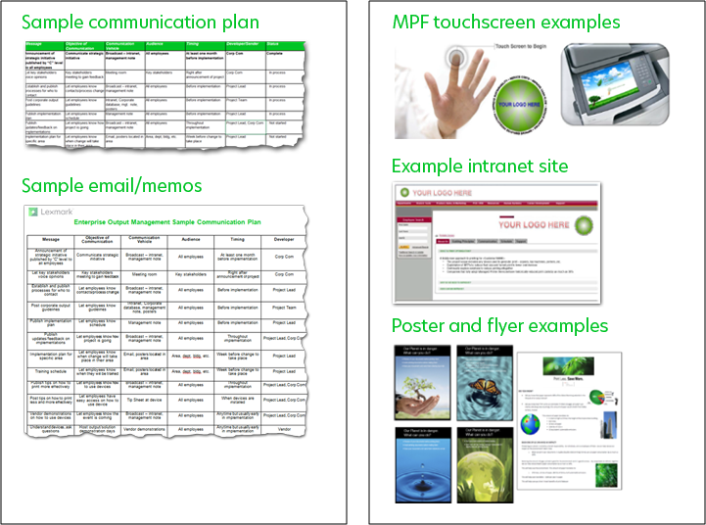

- Describe your ability to provide and support asset lifecycle management.

Asset management infrastructure

Effective asset management is a business discipline enabled by people, process, data, and technology to effectively manage the life cycle of assets to achieve a desired service level while mitigating risk and stabilizing operations to improve business performance.

Lexmark has invested heavily in creating a state-of-the-art infrastructure to automate many of the most labor-intensive MPS tasks. The ARMS is a full-function asset management application optimized for managing the life cycle of output assets. ARMS is focused on tracking, controlling, and documenting the movement of Lexmark-managed assets, including non-Lexmark third-party devices, throughout each of the nine phases of their life cycle.

The generally accepted definition of the asset management life cycle includes the following phases: plan, acquire, deploy, manage, fix, and retire. The ARMS application addresses each of those phases. The life cycle phases in ARMS are ordered, shipped, delivered, installed (or added), accepted, financed, billed, inactive and retired.

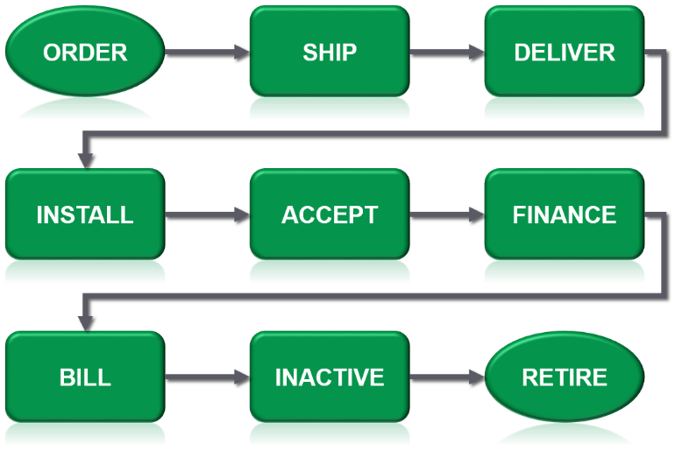

Whether the output fleet being managed numbers in the hundreds, thousands or tens of thousands, the Lexmark asset management infrastructure can efficiently manage each asset individually. Agency-defined hierarchy functions roll up the individual device-level data into meaningful specified views for workgroups, departments, divisions, and the entire enterprise.

The Lexmark asset management infrastructure supports a variety of business processes, including:
- Asset initialization
- Asset acceptance
- Customer agreement and pricing administration
- Meter read processing
- Change management (MADC) tracking and reporting
- Billing management
- Swaps
- Internal reporting/SLA monitoring
- External customer reporting
- Audit

Effective asset management requires effective collection of data from the devices being managed. Lexmark devices are developed and manufactured with services in mind and our unique vertical integration allows for robust data collection. Lexmark may utilize a variety of tools to ensure efficient and effective data collection from both Lexmark and non-Lexmark devices. One such tool is the LDCM.

The LDCM is implemented at the Participating State or Entity’s site to collect data on the output devices and deposit that information into the ARMS database in Lexington. The database will be constructed to support the Participating State or Entity reporting and billing requirements and hierarchy levels. We will work with the Participating State or Entity to understand how to provide reporting and billing on the asset database that is relevant to the key areas of your organization—i.e., management reporting for the distinct workgroups. the Participating State or Entity will have access to the Lexmark web portal to access fleet information on demand at any point in time. The visibility that the Lexmark asset management infrastructure provides enables us to become more proactive in our operational support and will give us the data that we need to turn information into actionable opportunities for savings.

Lexmark tracks all hardware configurations in our asset management database. Any changes to accessories and configurations will be communicated through a mutually agreed-upon and predefined process to ensure accuracy of the asset inventory data.

Lexmark has the capability to collect data on non-network-attached devices (USB only). This capability requires that a software client be installed on each network-attached PC with a locally attached Lexmark printer. Management and maintenance of this software client on the PC fleet is the responsibility of the Participating State or Entity. This is in contrast to network printers, where the LDCM polls the printers and thus provides a single point of control and responsibility regarding the data consistency.

If non-network printers exist in an environment where the PC and printer are almost always powered on, where network connectivity is reliable and where the collection software does not conflict with other PC software, then data availability (and thus reporting and device management) can approach that of network printers.

- Describe your ability to support cloud technology for print job management.

Lexmark offers a deployment method of our pull print solution that is entirely cloud based. Please note that the solution offered with this solicitation represents the premise-based version of Lexmark’s pull print.

The cloud version (LPM Cloud) maintains all application infrastructure required to support a pull print solution (e.g., hardware load balancers, print / application / SQL server(s), etc.) in a Lexmark-managed cloud environment. This deployment model removes the necessity for local/on-premise print servers, reducing the administrative burden for the I/T group managing the solution. This is accomplished by allowing the workstation client submitting the print job, whether it is a Mac/Windows workstation or mobile device, to communicate securely and directly with the Lexmark cloud—no gateways, premise servers, or VPN connections required.

All print jobs are stored in the Lexmark cloud until they are retrieved by the end user at the printing device or automatically purged after a designated amount of time. In addition, the solution offers the ability to store print job data local to the PC or Mac workstation instead of submitting to a cloud environment, which is particularly useful in locations where the bandwidth between the workstation and the cloud service is low (minimizes latency that can be introduced when traversing a large print job over a WAN). All user-level transactional behavior, print, copy, fax, and scan is captured at the printing device and reported on using an intuitive reporting engine maintained in Lexmark’s cloud environment.

The pull print environment in Lexmark’s cloud is set up and configured to be highly available with multiple redundancies to ensure consistent delivery of all print jobs without the need for user or administrative intervention to do so. In addition, the Lexmark solution can federate into any SAML 2.0–compliant identity provider, removing the need to maintain users in multiple solutions.

- Describe how your proposed technology will guarantee security solutions such as: intrusion detection, user authentication, protecting content integrity, and pull printing.

Lexmark multilayered security

Lexmark is an industry leader in document and device security, and Lexmark MFDs have been selected as the standard device for many areas of the federal government, including some of the most secure agencies within the US Department of Defense (DoD) and Intelligence. Device security is a complex issue, with many elements to consider. Lexmark devices are equipped with a wide array of industry-standard security functions and features that allow an organization to secure networked devices and their use. Lexmark’s security solutions offer protection of the device, the network, and the data involved in the use of the device. You may read the complete description of Lexmark’s security solutions for MFDs here: http://www.lexmark.com/content/dam/lexmark/documents/white-paper/y2017/security_white_paper_final-us.pdf.

Secure data on the MFD

Lexmark devices are equipped with non-volatile memory to store essential system information when the devices are turned off. Some Lexmark devices can also be equipped with a hard disk to buffer jobs or collate large jobs, or store forms, fonts, or macros. To run some printing applications or printer software solutions, a hard disk is required. The use of nonvolatile memory and hard disks are industry-standard methods for enhancing the performance of print and imaging devices.

Hard disk encryption
Lexmark devices can encrypt all data on hard disks to protect it from external access at all times. When this feature is enabled, all data written to a hard disk is encrypted. This protects not only residual data that remains after printing jobs, but it also protects data actively being used. This prohibits someone from turning off the device in the middle of a job and making use of the data left on the disk. The encryption key to be used (256-bit AES symmetric encryption) is pseudo-randomly generated and stored in a proprietary fashion in a device’s memory.

Non-volatile memory wipe
A non-volatile memory wipe erases a printer’s memory. Lexmark devices use two forms of non-volatile memory—Electrical Erasable Programmable Read-Only Memory (EEPROM) and negative-AND (NAND). These components store the device operating system, device settings, network information, embedded solution applications, various scanner settings and bookmark settings. No user-related print, copy or scan data is stored in non-volatile memory.
The printer memory erasing function (“Erase Printer Memory,” “Wipe All Settings,” “Erase all apps and app settings,” depending on the device model) deletes all content stored in the various forms of flash memory on the Participating State or Entity’s device. The Participating State or Entity can completely clear all settings, solutions, and job data on the device. This function is ideal when retiring, recycling, or removing a device from a secure environment.

Lexmark Secure Element
Lexmark’s Secure Element is an optional security component that is designed to enhance and protect the generation and storage of encryption keys used by a Lexmark device. It is a customer installable option or can be installed/shipped with the product at manufacturing. It is essentially a smart card that installs in a Lexmark device’s controller board in the same manner as a SIM card which can be found in mobile phones.
This technology grants additional layers to secure and highly capable Lexmark devices by enhancing its ability to protect the cryptographic keys that are generated by and installed on the device. In addition to providing a more secure key store, the Secure Element provisions the device with a method to generate cryptographic keys faster and with more complex random numbers.

Hard disk file wiping
The file-based disk wipe sanitizes the portion of the hard disk where job data was stored after a job has been processed so that no residual data can be read. “Complete,” “Out of Service” or “Sanitize all information on hard disk” disk erasure, which is explained later, erases the entire disk while the file-based disk wiping described in the following paragraph erases the portion of the disk where the job data was stored. Lexmark devices offer a single-pass or multiple-pass wipe that is compliant with the National Institute of Standards and Technology (NIST) and DoD.

Complete hard disk erasure
“Complete” or “Sanitize all information on hard disk” hard disk erasure wipes clean the entire hard disk. The Participating State or Entity should perform a complete hard disk erasure process before a device is removed from any current location. This function is different than those previously described. With the “Sanitize all information on hard disk” (also called “Complete Wipe Disk” or “Erase Hard Disk”) command, the Participating State or Entity can eliminate all contents of a disk.

Out of Service wiping
With the Out of Service command, the Participating State or Entity can use the functions of Wipe All Settings and Complete Hard Disk Erasure (Wiping) in one step when removing a device from service or removing it from a secure environment. To ensure that no customer data remains on the device hard disk, Lexmark recommends that the Participating State or Entity use both Wipe All Settings and Complete Hard Disk Wiping commands. With the Out of Service command (available on later firmware updates of most devices), the Participating State or Entity can choose to initiate both of these functions at the same time from either the Configuration Menu or from the device web page.

Physical lock support
Lexmark devices support cabled computer locks, which you can use to physically secure the devices’ critical and sensitive components, such as the controller board and hard disk.
Lexmark devices deliver a very strong security story by providing our customers with comprehensive security capabilities that address our customers’ real-world security issues by flexibly integrating our device capabilities to our customer’s network environment. The bottom line is, Lexmark devices have effective security without lowering user productivity.

LDCM data security

A number of countermeasures are taken to reduce the risks of potential threats, vulnerabilities, and maintain data confidentiality, privacy, integrity, and availability. The objective is to achieve a balance between a reasonable secure operation, which does not unduly hinder users, and the costs of maintaining it.

The LDCM software appliance has been designed and is expected to be placed in low threat environment. The hardware hosting the LDCM software appliance is expected to be placed in a physically secured location, and only trusted, authenticated, and authorized users are allowed to establish a user session on the host operating system. Lexmark recommends placing the LDCM software appliance within the customer’s internal network secured behind the firewall, and not in a network directly exposed to external networks (i.e., the internet).

The LDCM Oracle XE database is configured such that it will not accept any Transparent Network Substrate (TNS) connections, from the local host or outside the LDCM host. This means Oracle Application Express (APEX) and remote connections will be disabled. To leverage most Oracle vulnerabilities in the core Oracle database software requires the ability to establish a valid session with the database before performing the exploit. The measures described above prevent a potential attacker from making a connection to the database remotely and therefore prevent leveraging the exploit.

All network communications that take place between LDCM and the web servers located within Lexmark’s data centers are based on HTTPS. Lexmark uses an HTTPS combination of encryption technologies named asymmetric encryption (elliptic curve Diffie-Hillman) and symmetric encryption (AES). Asymmetric encryption is based on the use of a public/private key pair, in which the key used to encrypt the data cannot be used to decrypt the data. Elliptic curve Diffie-Hillman encryption is used to securely exchange a shared key that is used in a symmetric encryption algorithm such as AES.

Using X.509 certificates as a key exchange technology, LDCM can be configured to take advantage of some additional benefits. For instance, when LDCM requests a connection back to the Lexmark web servers, it also requests an authenticated connection. By utilizing a DigiCert signed certificate on the web server, Lexmark has made every effort to ensure that customer information is only sent to the correct systems. When LDCM establishes the secure connection back to Lexmark, the signed certificate provides assurance that the LDCM is in fact communicating with a valid Lexmark system.

Security solutions we are offering NASPO and the Participating State or Entity

Your Lexmark laser printer or smart MFD can run security-related apps to fill special needs like Print Release (pull print), automatic security certificate enrollment and smart card authentication. Another solution that can be offered can centrally track and audit every document that’s printed, copied, scanned, or faxed on your network.
- Secure Print Release: LPM lets users send jobs from anywhere and pick them up at any Print Release-configured device on your network. You’ll improve printing flexibility, avoid having documents piling up on printers, protect the confidentiality of documents that would otherwise be out in the open, and save on printing costs. And the whole release process is secured by credentials entered at the device, in the form of network user identification or an ID badge.
- Contactless card authentication support: Badge authentication solutions include contactless card solutions (applications) for basic badge authentication. This option is available when user identity is linked to office security ID badges. The solutions can verify the badge ID and retrieve user information so the Lexmark device can access held print jobs, identify the source of scanned documents, or identify a user for other purposes.

- How do you handle network and data security issues? What measures do you take to protect sensitive customer information?

Security and Privacy

Lexmark respects the privacy of our customers and takes safeguarding their personal information very seriously. We have no customer complaints regarding any breach of personal information collected through Internet marketing and sales activities.

Security of customer information

To protect against unauthorized access, misuse, disclosure or alteration of personal information, Lexmark uses appropriate physical, technical, and administrative security measures. Physical security is designed to prevent unauthorized access to data center equipment and hard copies of documents. Electronic security measures—such as firewalls, access restrictions and encryption—provide protection from unauthorized access. Lexmark limits access to personal information to those persons in our organization, or agents of Lexmark, who have specific business purposes for maintaining and processing personal information and data. Lexmark regularly reviews privacy compliance.

Lexmark offers recourse to customers who feel there may have been a breach of their personal data. Designated e-mail and postal addresses are available:
privacy@lexmark.com
Lexmark International, Inc.
Privacy Mailbox
740 West New Circle Road
Lexington, Kentucky 40550

ISO 27001 is an information security management system (ISMS) international standard that provides a comprehensive set of requirements for maintaining confidentiality, integrity, and availability of data. Lexmark has ISO 27001 certification for its worldwide MPS ISMS.

Lexmark designs products to meet ISO/IEC 15408 Common Criteria Certification, an international standard on security capabilities. Lexmark is committed to validating this design through both the IEEE 2600 family of standards and the U.S.-based National Information Assurance Partnership’s (NIAP’s) Hard Copy Device Protection Profile (HCDPP).

Lexmark also follows the Federal Information Processing Standards (FIPS) 140 Publication Series issued by the National Institute of Standards and Technology (NIST), which outlines requirements and standards for cryptographic modules, including both hardware and software components. Adherence to this standard for hard disk encryption and IPsec networking helps Lexmark provide the necessary conditions to secure information.

- Describe your remote device monitoring services. Do you obtain meter reads automatically? Do you have an automated toner replenishment program?

Lexmark has the ability to collect meter reads (page counts) and a wide variety of other data from both networked and non-networked devices.

For output devices that are on the network, Lexmark has developed tools and systems that allow for the collection of data (including meter reads and other usage data) from those devices in an efficient and timely manner, with minimal impact to the customer’s environment. The LDCM is used by Lexmark to facilitate this requirement and increase the efficiency in MPS engagements.

LDCM is a suite of Lexmark proprietary applications that resides on a dedicated networked server or personal computer (PC) within the customer’s network, performing the following tasks:
- Device monitoring
- Device discovery
- Data transmission

By having LDCM perform its scheduled tasks in an automated manner, the Participating State or Entity resources would be able to concentrate on performing the operations and services that they offer to their customers, rather than having to manage your internal output devices on a daily basis. The data collected by LDCM is hosted and managed by Lexmark and all data collected is treated as strictly confidential. The LDCM technology coupled with Lexmark’s proven business processes/methodologies ensure a continuous and highly efficient capture of data from the managed devices on an ongoing basis.

For non-network devices, Lexmark supports collection of meters and other usage data from Lexmark single-function and multifunction laser devices that are connected via USB cable to a Microsoft Windows PC or workstation. Lexmark MPS does not support local-attached devices connected by parallel or serial cable. The collection of data from locally attached (non-networked) devices is accomplished by using the Local Printer Management Agent (LPMA) utility with the MPS plug-in. The LPMA utility will monitor the USB-connected device, perform certain data collection actions, and communicate those collected data elements back to Lexmark systems through the LDCM server that would be deployed on the customer’s network. The LPMA utility is deployed to a targeted set of Windows PCs or workstations that have non-network, USB-connected device attached to them. The LPMA utility can be deployed and configured to individual PCs or broadcast deployed by the customer’s network administrators via the available MSI package.

Proactive Consumables Management

Lexmark’s Proactive Consumables Management (PCM) services is a standard offering within the Lexmark MPS offering. Lexmark’s automated consumables management program provides consumables where the Participating State or Entity needs them and when the Participating State or Entity needs them, avoiding the excess purchase of expensive supplies.

Once our core services are implemented and we are managing the customer database of assets, we collect consumable alerts produced by output devices. It starts with the detection of the need via the front-panel alerts on the output device via the LDCM. The alert information captured by the LDCM is transmitted to Lexmark’s Consumables Management System (CMS) via Hypertext Transfer Protocol Secure (HTTPS) over port 443. When we receive the alert, CMS validates whether the output device is active in the database and then checks the need for the consumable item against a set of business rules—the device serial number/type/IP address combination are under management and that the requisite number of pages have printed since the last toner-low event on that device. This ensures the right consumable is shipped for receipt at the end-user workstation, avoiding duplicate orders.

Once the alert has been validated, the system then automatically sends the supplies order to Lexmark’s supply chain for fulfillment. The Participating State or Entity receives notification when order is placed. Once the order has been shipped, the Participating State’s or Entity’s key user will receive an e-mail notification. With this notification, the Participating State or Entity can track the order until delivery giving you complete visibility. The following diagram shows how the process works.

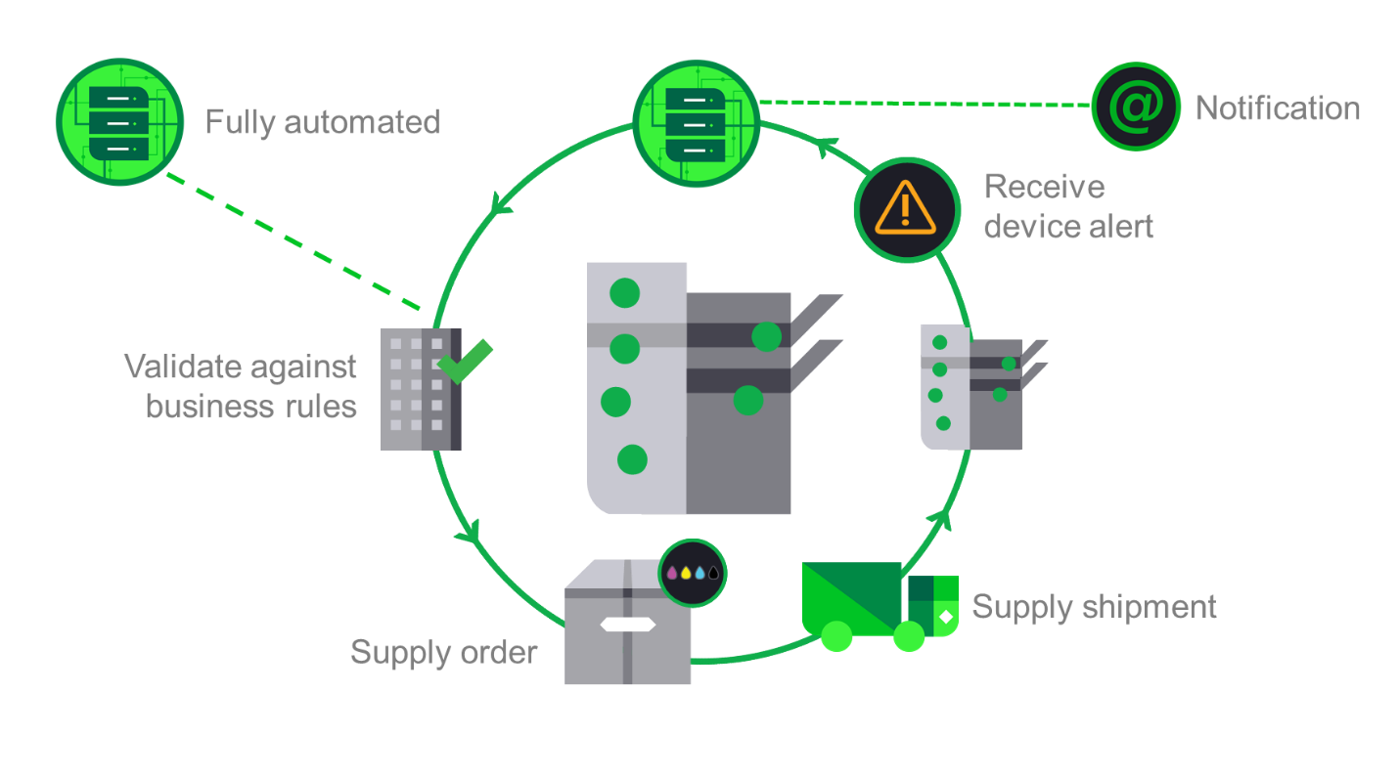

Lexmark’s program includes all toner and maintenance kits. In our proactive service model, we will not only automatically send a maintenance kit, but we will also dispatch a technician to install the maintenance kit when it arrives as a preventative maintenance measure. The end-user notifications are customized so the end user knows that the maintenance kit has been ordered and will be installed by a technician with no responsibility on their part.

The components of our proactive detection, order, shipping, and recycling is detailed here in point form:
- Consumables need identification—Lexmark tools can electronically detect the need for toner cartridges, maintenance kits, staples, and photoconductors. This results in the proactive shipping of consumables and the replacement of maintenance kits. All devices on the network will be monitored proactively regardless of urban versus rural locations.
- End users can request consumables from Lexmark for devices that are not connected.
- Order authorization—Lexmark will perform a rules-based order authorization function prior to routing a consumable order. Lexmark’s CMS automates the entire process. The system validates the correct consumable for the device, validates the shipping information, location and contact for the device.
- Consumable fulfillment—Consumables will be fulfilled through a reseller who will coordinate the delivery of these required consumables to the required location and load on behalf of the user. The system provides all relevant information to perform the consumable replacement including device, location, machine serial number and contact information.
- Exception management—If an order fails the order authorization process, Lexmark will generate an exception report that will be routed to the appropriate personnel.
- Route orders—Lexmark’s system will route orders automatically to the reseller.
- Removal and environmental recycling of spent cartridges will be performed by Lexmark as part of our environmental initiatives and Lexmark’s Cartridge Collection Program (LCCP). The program provides for the direct return of the empty cartridge to Lexmark via a prepaid label contained in the carton of the new cartridge. The end user or key operator simply places the used cartridge in the box of the new one, affixing the prepaid label to the box and staging it for return shipment.
- Track consumable shipments and equipment utilization to report as part of our SBRs.
- Visibility—Lexmark will set up a web portal that can be accessed by any users within the Participating State or Entity environment. Users will be able to view up-to-date order status (accepted, shipped, delivered and the like) as well as tracking numbers associated to each of the orders (where available).
- Orders for non-networked or local devices can be communicated by phone, fax, or e-mail to Lexmark’s Service Delivery Manager or to the help desk.

We believe that automating this monitoring function using software, algorithmic analysis, and automatic order generation and notifications for networked devices will eliminate any potential outage situation. This speaks to the capabilities of our tools in that detection of consumables goes beyond merely toner. We can detect front panel alerts for virtually all replaceable components, not just toner.

Lexmark will proactively monitor for consumable requirements on networked devices, automate the order and delivery process. We will strategically stock consumables at hubs and, where possible, at the Participating State or Entity facilities. We will partner with a reseller for delivery. The main reason for this is security clearance of reseller employees and adherence to the Participating State’s or Entity’s business practices, code of conduct, and protection of confidential information that may be at the output device while this function is being performed.

Using these proven systems, locally maintained inventory, and closed-loop delivery, we can fulfill the Participating State’s or Entity’s requested consumable service levels regardless of device location (urban or remote). Automated consumable detection and delivery is contingent on devices being on the network where they can be monitored, managed, and measured. However, should certain devices not be connected, we have provisions for end-user ordering and sufficient inventory management that will mitigate the risk of toner outage situations.

Our consumables management process will yield the following benefits for the Participating State or Entity:
- Consistent budgeting and pay for use by enabling a variety of invoicing models, including cost-per-page mode
- Flexibility to have fulfillment done directly with Lexmark or with partners
- Reliable, high-quality, high-yield, Lexmark-manufactured products
- Freedom from tasks related to ordering consumables and maintaining stock levels
- Just-in-time delivery, with no expensive stockpiling of materials that become obsolete over time
- Direct recycling of products with Lexmark
- Order history and status viewable in Lexmark’s customer web portal

- Describe any recycling programs that you offer and how customers can utilize them.

Lexmark recognizes the value of robust recycling programs and provides programs for both hardware and cartridge recycling: Lexmark Equipment Collection Program (LECP) and Lexmark Cartridge Collection Program (LCCP). Our programs are easy for the customer to use and the products returned are reused or responsibly recycled with the highest industry standards and best practices for environmental responsibility.

Equipment collection

Lexmark offers our customers environmentally sound choices for disposal of their end-of-life products. Electronic waste, including printers that have reached the end of their usable lives, is recycled through our LECP by specialized firms with processes to meet state and legislative requirements. The firms we choose are committed to recycling devices in an environmentally and socially responsible manner.

End-of-life electronic product recycling
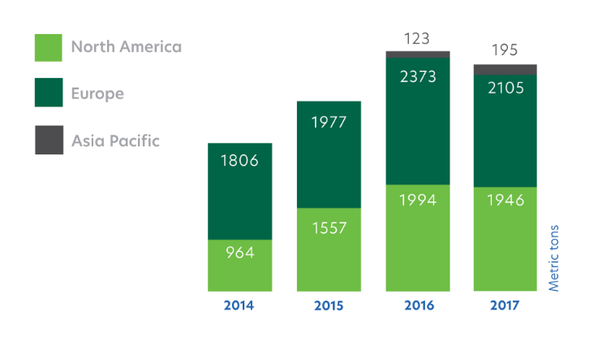

Lexmark partners with recyclers that offer a broad range of services and processing capabilities, have a proven record of compliance with government-mandated criteria for recycling facilities, are ISO 14001 certified (the environmental-management-system standard), and are certified R2 or e-Stewards.

Cartridge return and recycle

Lexmark continuously seeks new ways to reduce its footprint. While making great strides in waste reduction at our global manufacturing facilities, Lexmark also provides an opportunity for our customers to reduce their waste and increase the number of Lexmark products that are reused and recycled.

Cartridge collection

Our extensive cartridge collection network has made Lexmark an industry leader in the recovery, remanufacturing, and recycling of used toner cartridges. In 2017, through the efforts of Lexmark customers, more than 40 percent of the total toner cartridges shipped worldwide were returned through the LCCP. In some regions, the return rate was higher. For example, the United States continues to average approximately 50 percent return rates. We estimate the industry average collection rates to be between 20 and 30 percent.

Lexmark toner cartridge collections
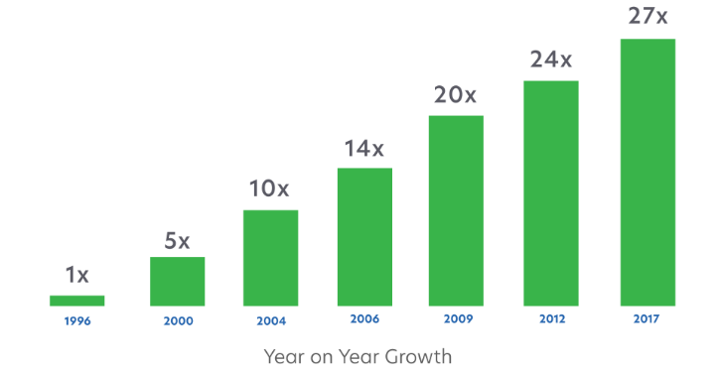

In 2017, we recycled or reused more than 7,000 metric tons of plastic, metals, and packaging, and were able to materially recycle or reuse 100 percent of the reclaimed plastic. Conserving materials for reuse in our products means fewer raw materials to be mined or extracted, thus reducing the impact on the environment.

For additional information on Lexmark’s LCCP program, please visit: https://csr.lexmark.com/return-recycle.php, https://www.lexmark.com/en_us/products/supplies-and-accessories/collection-and-recycling-program/lccp.html, and https://www.youtube.com/watch?v=R3X1B_bIY1Q.

- Please describe how you will monitor and manage print devices to include:
- Network access
- Fleet configuration and utilization
- Management of customer owned or legacy equipment, including parts, labor, supplies, and moves
- On-going assessments, which shall include, but not be limited to: continuous process improvement, device utilization, fleet performance, cost saving opportunities, green spend, consumables spend, break/fix, and service level standards
- Removing and disposing of Devices, including recycling programs that you offer and how a customer can utilize that program

Device Management, Monitoring, and Reporting

Effective asset management is a business discipline enabled by people, process, data, and technology to effectively manage the life cycle of assets to achieve a desired service level while mitigating risk and stabilizing operations to improve business performance. Since our inception, the cornerstone of our MPS offering has been to provide ongoing visibility to our customer’s asset infrastructure to drive meaningful reporting to make informed business decisions with a focus on continuous improvement.

Our proposed MPS solutions include the toolset that we utilize to provide proactive management in all our MPS engagements. We have invested over $250 million in a Siebel-based asset management system that provides the engine to enable visibility into the asset fleet, reporting, proactive monitoring and automating processes such as invoicing and consumables fulfillment. This asset management system can manage devices globally and provides live information about the health of the fleet, the details of every single service request (down to the individual service technician who fixed the device), change requests, and consumables management metrics. We provide a portal to all our MPS customers to access this data, which also tracks our performance as it relates to SLAs.

Management and Monitoring Infrastructure

Lexmark has invested heavily in creating a state-of-the-art infrastructure to automate many of the most labor-intensive MPS tasks. The ARMS is a full-function asset management application optimized for managing the life cycle of output assets. ARMS is focused on tracking, controlling, and documenting the movement of Lexmark-managed assets, including non-Lexmark third-party devices, throughout each of the nine phases of their life cycle.

The generally accepted definition of the asset management life cycle includes the following phases: plan, acquire, deploy, manage, fix, and retire. The ARMS application addresses each of those phases. The life cycle phases in ARMS are order, ship, deliver, install (or add), accept, finance, bill, inactive and retire.

Whether the output fleet being managed numbers in the hundreds, thousands or tens of thousands, the Lexmark asset management infrastructure can efficiently manage each asset individually. Customer-defined hierarchy functions roll up the individual device-level data into meaningful the Participating State or Entity specified views for workgroups, departments, divisions, and the entire enterprise.

The Lexmark asset management infrastructure supports a variety of business processes:
- Asset initialization
- Asset acceptance
- Customer agreement and pricing administration
- Meter read processing
- Change management (MADC) tracking and reporting
- Billing management
- Swaps
- Internal reporting/SLA monitoring
- External customer reporting
- Audit

Effective asset management requires effective collection of data from the devices being managed. Lexmark devices are developed and manufactured with services in mind and our unique vertical integration allows for robust data collection. Lexmark may utilize a variety of tools to ensure efficient and effective data collection from both Lexmark and non-Lexmark devices. One such tool is the LDCM.

The LDCM will be implemented at the Participating State or Entity’s site to collect data on the output devices and deposit that information into Lexmark ARMS database. The database will be constructed to support the Participating State or Entity reporting and billing requirements and hierarchy levels. We will work with the Participating State or Entity to understand how to provide reporting and billing on the asset database that is relevant to the key areas of your organization—i.e. management reporting for the distinct workgroups. the Participating State or Entity will have access to the Lexmark web portal to access fleet information on demand at any point in time. The visibility that the Lexmark asset management infrastructure provides enables us to become more proactive in our operational support and will give us the data that we need to turn information into actionable opportunities for savings.

Lexmark tracks all hardware configurations in our asset management database. Any changes to accessories and configurations will be communicated through a mutually agreed-upon and predefined process to ensure accuracy of the asset inventory data.

Lexmark has the capability to collect data on non-network-attached devices (USB only). This capability requires that a software client be installed on each network-attached PC with a locally attached Lexmark printer. This is in contrast to network printers, where the LDCM polls the printers and thus provides a single point of control and responsibility regarding the data consistency.

If non-network printers exist in an environment where the PC and printer are almost always powered on, where network connectivity is reliable and where the collection software does not conflict with other PC software, then data availability (and thus reporting and device management) can approach that of network printers.

The Lexmark project manager (PM) oversees the implementation of all required tools to enable device management, monitoring and reporting as described above.

Lexmark’s monitoring capabilities enable remote access to the fleet of output devices so device-specific conditions can be identified, diagnosed, and acted upon in the most efficient manner possible. By design, this is intended to ensure maximum uptime and end-user satisfaction.

Remote monitoring is the most effective way to manage a large fleet of output devices. Proactive maintenance and support will be performed utilizing Lexmark’s proprietary toolset and can be done remotely, on the Participating State or Entity’s site or both remote and on-site.

Proactive management is comprised of the following items:
- Proactive device monitoring
- Proactive Consumables Management
- Configuration management
- Maintenance service
- Help desk integration
- Tracking and reporting
- Global services portal
- MPS governance

Finally, from a monitoring perspective, we have integrated an analytics platform into our asset management database that provides two unique capabilities to Lexmark and sets us apart from our competition.
- Predictive Service: Thanks to our asset management system and technology-based approach to MPS we’ve created an analytics engine that captures, interprets, and analyzes device data—allowing us to automatically take action to keep your fleet at peak performance before any outages occur. Our system detects potential issues and will automatically initiate service requests—bypassing the need for users or IT staff to call the help desk or enter a trouble ticket. Predictive Service takes proactive monitoring to a new level. We are no longer waiting to see an error alert and then “reacting” to that alert. We are truly predicting an error or outage before it occurs. With Lexmark Predictive Service, you’ll realize many benefits, including the following:
  - Reduction of print-related help desk calls by up to 29%
  - Increase in remote fix by up to 20%
  - Decrease in service technician dispatch by 14%
- Predictive Analytics: Leveraging the same analytics platform, our consulting team is able to glean more meaningful data, trending, and information from the fleet to detect inefficient areas in your environment. We then deploy our consultants to analyze these areas and identify solutions that drive efficiencies focused on continuous improvement.

Lexmark MPS Process Analytics

While standard reporting is good, our experience has shown that to drive maximum page reduction and identify opportunities for process improvement requires joint collaboration between ourselves and our customers. We achieve this through our governance process, which a key element of Lexmark’s MPS program. As part of our governance process, we actively mine the information received through our fleet tools, as well as from our LPM platform, to help customers drive continuous improvement. For some customers, it is about device optimization. For others, it is about user behavior and department usage. For many, it is about identifying the outliers and the process that is driving the page volume. And for all, it is about supporting sustainability initiatives.

Lexmark uses analytics to gain better insight into output behavior, as well as process behavior. With our operational intelligence platform, we are able to turn the data we collect from the devices into meaningful insights. Lexmark will collect statistics relating to output behavior for every managed Lexmark device within the Participating State or Entity’s fleet. This data includes information around copy, print, scan and fax and is examined at an account, location, and business function and device level. As part of our closed-loop governance process, we leverage analytics to find areas for continuous improvement. We examine behavioral trends and identify anomalies.

We start at the industry level, determining where the Participating State or Entity rates against industry averages and peers through benchmarking and scoring. Then we begin to analyze at the account level, looking at the trends and identifying outliers. We identify locations of interest and drill down on that data to identify hot spots, which could be physical locations or a particular line of business. Once we identify those, we can go all the way down to the device level (if necessary) to see if the behavior only occurs within a certain cluster of devices.

From there, we work with our customers to understand business processes within these locations or lines of business to determine how to optimize processes by leveraging Lexmark smart MFDs and their integration with our industry solutions.

Features/Benefits
Lexmark is investing heavily in Lexmark MPS Process Analytics to make our MPS smarter, so we can offer our MPS customers a variety of improvements:
- Benchmarking industry best practices—Lexmark MPS Process Analytics will provide insight into how effectively the Participating State or Entity has implemented industry best practices for output. We will monitor the Participating State or Entity’s output behavior in relation to your peers, evaluating and updating best practice statistics to make sure your output strategy is delivering as intended.
- Identify internal outliers—To identify internal outliers, we employ a robust methodology in our analytics that uses over 150 different metrics. We approach our analysis through lean processes, with the ultimate goal to add value and eliminate waste. Because of our single global system, we will have worldwide visibility to your fleet, providing you detail and analytics all the way from a global view down to a location-by-location basis. This approach provides detailed behavior—copy, scan, print, fax, copies to originals and other metrics at a line of business level.

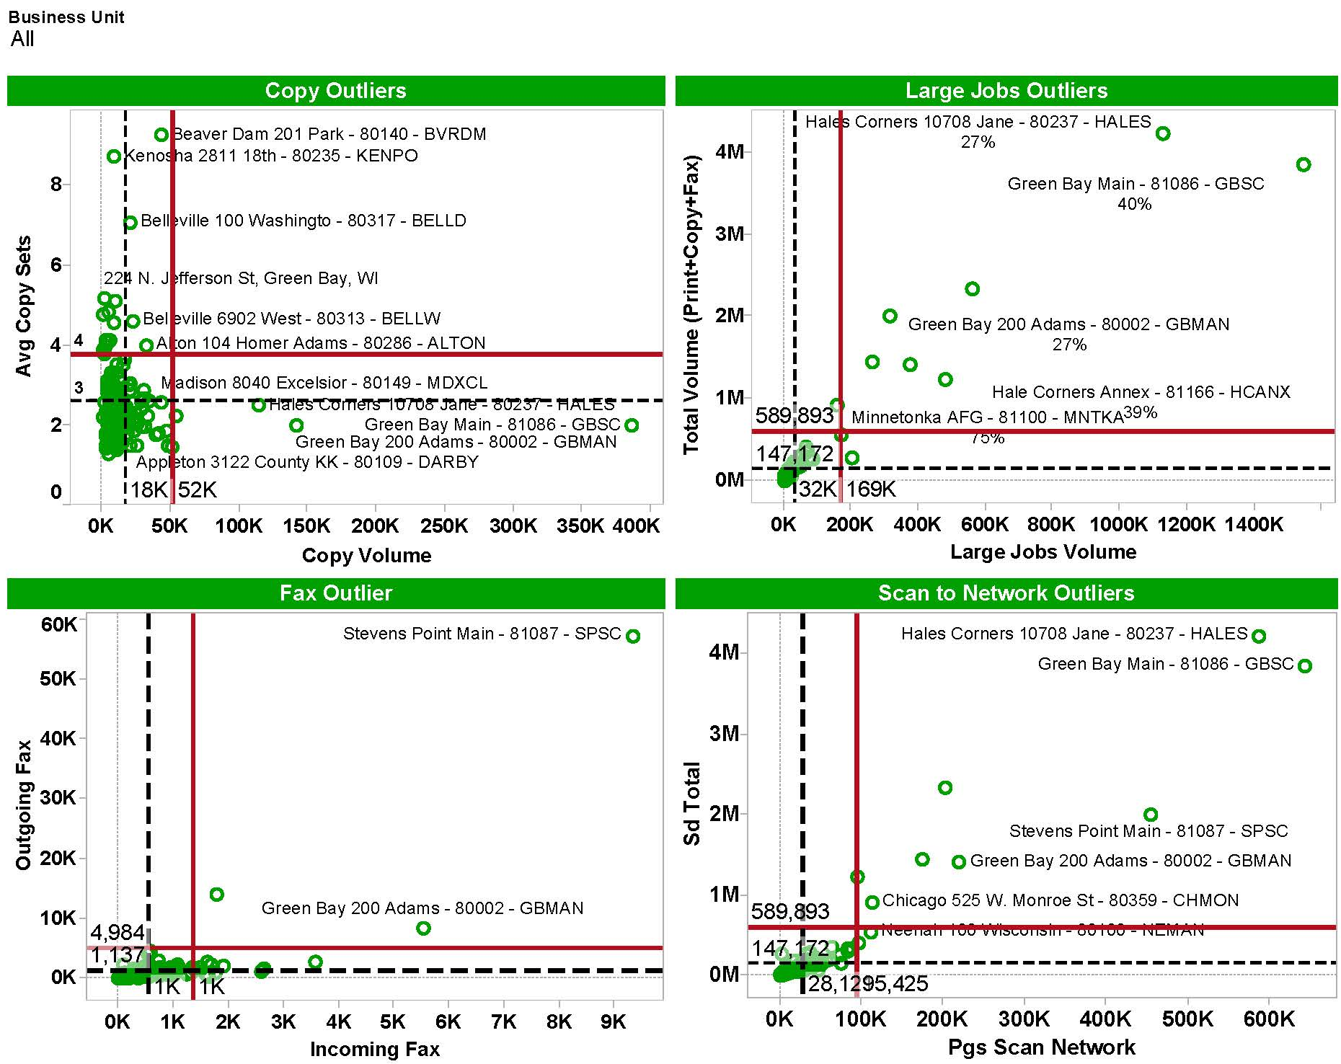

- Monitoring behavior trends—Because we continuously collect data on the managed Lexmark fleet, we are able to provide valuable insight about output behavior over time, not just at a single point in time. This will allow us to understand the historical peaks and valleys of activity in the Participating State or Entity’s output environment in order to spot both positive and negative trends.

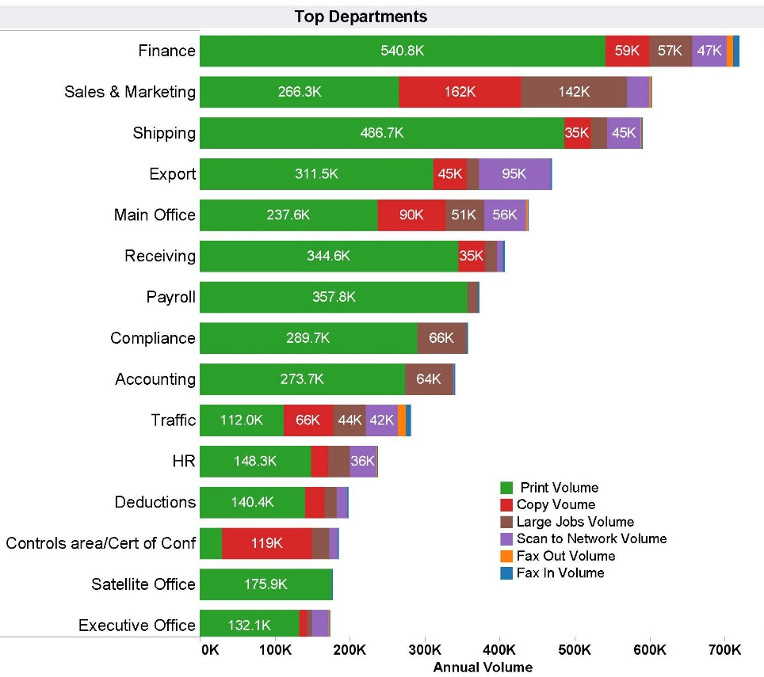

- Illuminate process improvement opportunities—Once we have identified trends and behaviors, we will analyze the Participating State or Entity metrics to highlight potential process issues—allowing us, and you, to make the most informed decisions about your fleet. A variety of measurements we continuously monitor, such as paper size, scanning location and copies to originals, can indicate paper-dependent processes. By isolating data from specific line of business functions, locations, and devices, we can then assess and provide you with process improvement opportunities.

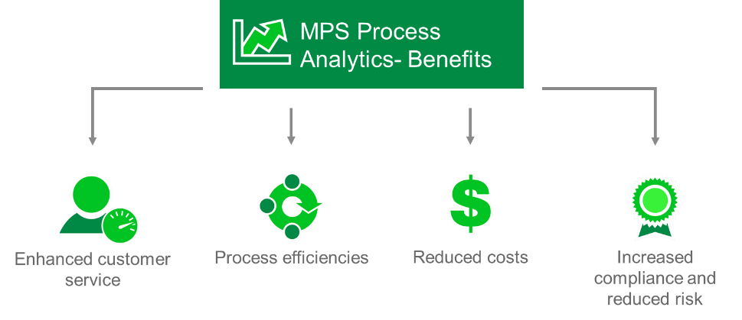

Lexmark MPS Process Analytics can take valuable insight further into actionable information so the Participating State or Entity can enjoy these benefits:

Lexmark MPS Process Analytics: Real Customer Examples

Lexmark MPS Process Analytics were used to identify “Top Outliers” in this customer’s fleet. In this specific case, it became clear that one of their locations was scanning almost triple the volume when compared with their other locations. Lexmark’s MPS Process Analytics was able to pin point the anomaly of scanning volumes at that location and it prompted a closer look at the underlying workflows that might be driving the additional volume.

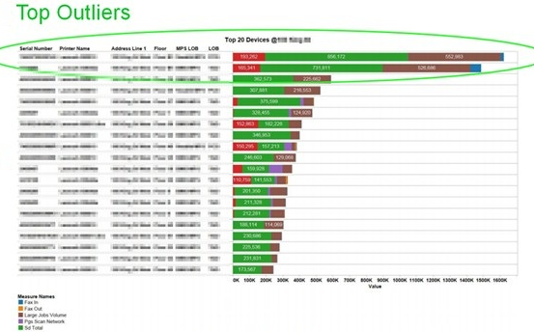

A Lexmark business consultant conducted a workflow analysis of one of the customer’s back-office scanning workflows and created a Process Workflow Map that followed the scanned documents through their life cycle.

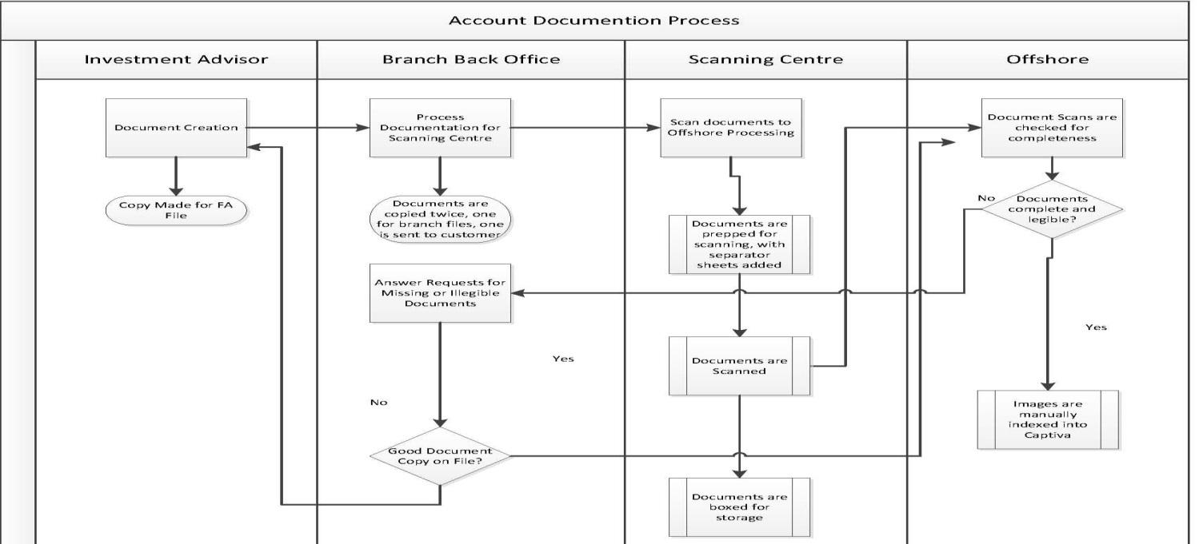

A detailed summary of all cost elements was captured, and a business case was built and presented to the customer for consideration. In this specific example, the business case developed by the Lexmark business consultant demonstrated the opportunity for the elimination of approximately $20 million in hard costs and their associated labor costs in the current workflow.

By using data analytics Lexmark was able to bring value to the customer by highlighting a change in their business processes that would bring them significant cost savings. These savings would be the result of adding a distributed scanning workflow to the existing MFDs at the site level, eliminating additional “shadow copies” of documents at various stages of the workflow, and removing the requirement of the back office off-shore bulk scanning operation.

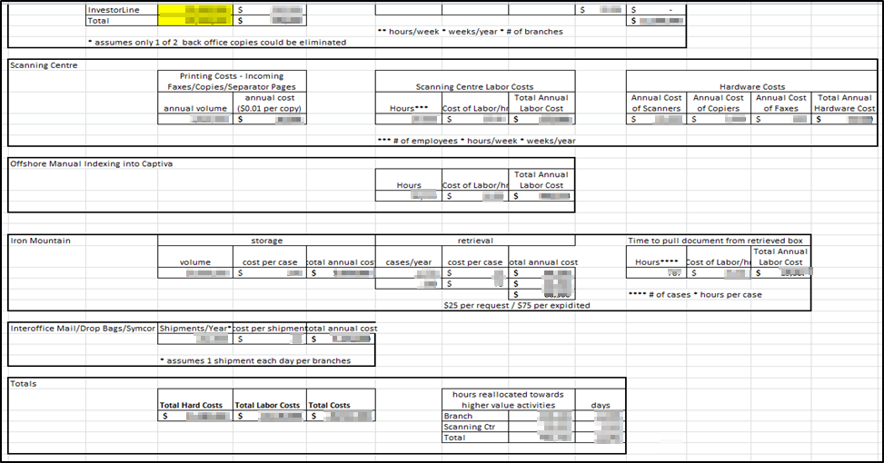

By having strong benchmarking data, Lexmark has been able to identify trends and behaviors specific to the customer’s environment. This benchmarking and continuous monitoring has provided the customer with process improvement opportunities that help them identify cost-saving opportunities, streamline their paper-based processes, and become more productive, giving them a competitive edge in their industry.

A second benchmarking exercise was done with a focus on Fax in the customer’s environment. Lexmark was able to show them how they compared to industry benchmarks. The benchmark data examined Fax In and Fax Out volumes. The diagram that follows demonstrates that they were faxing approximately two to three times the industry benchmark.

Lexmark was also able to show the customer their trend line was slowly decreasing over time, but a significant volume of Fax traffic still existed their environment.

Further assessment of the Fax environment is anticipated, and Lexmark and the customer will be investigating fax-over-IP solutions to lower the cost of faxing overall.

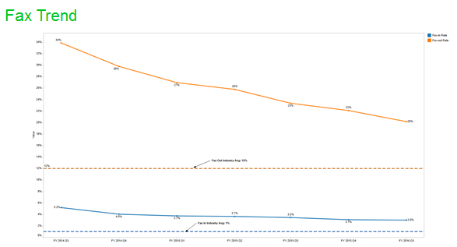

Finally, to better understand how we leverage our people, processes, and tools to analyze output and device usage far beyond standard reporting, please consider the example that follows. The illustrations represent the efforts of our governance process, where we are focusing on the outliers within the customer’s environment. We are following the paper trail to identify ways to remove the paper and make the process more efficient. For this specific customer, our joint partnership together has allowed us to take them from 400 million annual pages to today under 100 million annual pages.

We are excited about engaging with the Participating State or Entity to identify your key priorities and needs around reporting and share with you specifically how we can best help you achieve your objectives and drive actionable outcomes. Lexmark’s proven business analytics and benchmarking methodology aligns perfectly with the Participating State or Entity’s stated business outcomes and objectives of aggressive costs savings, enhancing the quality and reliability of your MPS offering and obtaining expert advice on how to strategically manage your printing needs, new technology and solutions.
Markvision Enterprise Fleet Management Software

Lexmark Markvision Enterprise is free, browser-based software that gives you complete visibility into your entire fleet of network printers and MFDs, regardless of manufacturer. This advanced, yet easy-to-use toolset helps you realize a fast return on your printing device investment, whilst reducing the burden on your IT staff.

Managing your device fleet is simple and intuitive

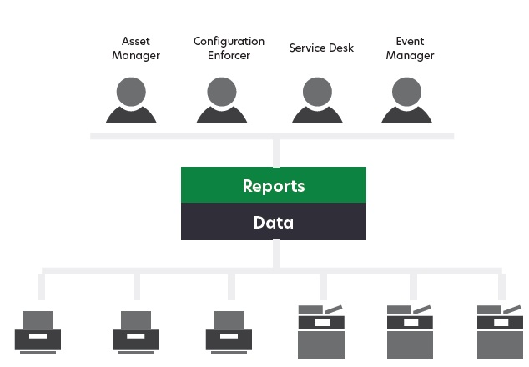
Roles-based design
To coordinate the multiple tasks involved with managing your devices, the software is divided into four service areas: Asset Manager, Configurations, Service Desk, and Event Manager.
This roles-based design benefits administrators and users alike; administrators can grant access based on individual users’ responsibilities, and users are presented with only the features and functions they need to accomplish their jobs. In addition, the software models ITIL terminology and methodologies, the best practice framework used by IT service managers around the world.

Intuitive user interface
The user interface meshes outstanding functionality with a superb visual design to provide a user experience that is intuitive, consistent, and very easy to use.

Web-based
Once installed, Markvision Enterprise is accessible from anywhere on the network using your Web browser. There is no need to install separate client software.

Easy to scale, up or down
Markvision Enterprise lets you centrally manage your entire fleet, whether you have a few devices or thousands. Lexmark testing was reliably conducted with up to 20,000 devices on a single server.

Four powerful tools to help you manage your output environment more effectively

Lexmark Markvision Enterprise device management software lets you track and troubleshoot both Lexmark and non-Lexmark devices throughout their life cycle—from the moment you connect them to the network, until the day you retire them.

Asset Manager

Markvision Asset Manager discovers your devices, collects information from them and allows you to organize devices into groups so you can perform searches, efficiently schedule tasks, and keep track of assets throughout their life cycle. With Asset Manager, you can:
- Auto-discover devices or import a list of your devices
- Create discovery profiles and run them on a scheduled basis to keep your list of assets up to date
- Audit devices to gather information, such as installed features, options, page counts and other statistics
- Search and group devices based on attributes and then bookmark the results so you can access them any time
- Track assets throughout their life cycle and automatically monitor for changes
- Generate inventory reports in PDF or CSV format to better understand the makeup of your fleet and share information with decision makers

Configurations

Once you have discovered and organized your devices, Markvision makes it easy to configure them, update their settings and ensure the devices remain properly configured over time—all from a central location through your web browser. With Configurations you can:
- Create reliable, flexible configurations that define the specific settings you want for a group of devices
- Automatically check devices for conformance with their configuration
- Enforce configurations, either manually or automatically, to keep devices configured exactly the way you have defined
- Update firmware and automatically ensure devices are kept at the correct firmware level
- Deploy Lexmark solutions to your devices

Service Desk

Markvision Service Desk lets you interact with your devices in real time, giving you the tools you need to troubleshoot and correct issues as quickly as possible. With Service Desk, you can:
- View the status of a device
- View configuration information to quickly identify if the device is conforming with its configuration and enforce them if the settings have been changed
- Remotely interact with the device, either through the device’s embedded web page or through the remote operator panel. Access to the remote operator panel is supported on all newer Lexmark models, and allows you to change settings as if you were physically at the device

Event Manager

Whereas Service Desk allows you to intervene when a problem occurs, Markvision Event Manager helps you intercept issues by proactively monitoring your devices, alerting you to events and launching automatic actions when those events occur. With Event Manager, you can do the following:
- Monitor events in your fleet, such as low consumables or error conditions
- Automate your response to an event once the alert is received using either an e-mail notification or, if a custom action is required, event information can be written to a file

Designed for IT

Once installed, Lexmark Markvision Enterprise is accessible from anywhere on the network using your Web browser; there is no need to install separate client software. The server discovers and communicates with devices on your network and provides the information to the client. The client displays the information through an intuitive, roles-based interface so you can easily see and report on your devices. This powerful solution lets you centrally manage your entire fleet, whether you have a few devices or thousands on your network.

The removal of devices, either devices at the start of a contract or at the end of our term can be included as a negotiated aspect of the contract. A customer’s inclusion into that recycling program is included with the removal of the device and does not need to be opted into by the customer.

