Leetron Vision
Iowa DOT RFB-185-2527-2026
AI-Enhanced Continuous Count System
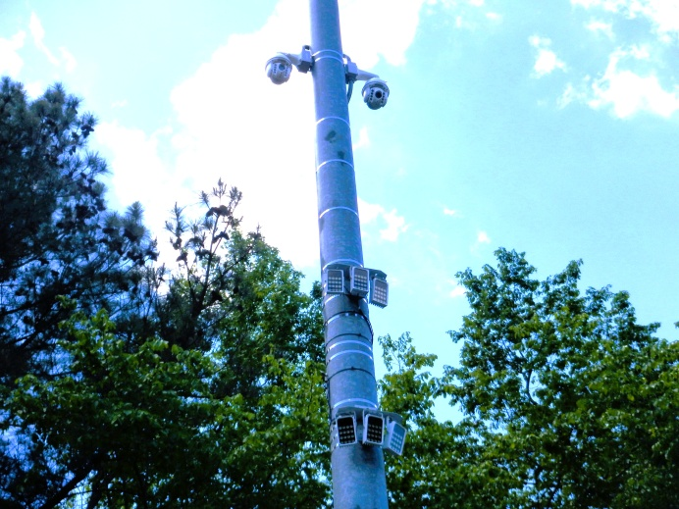
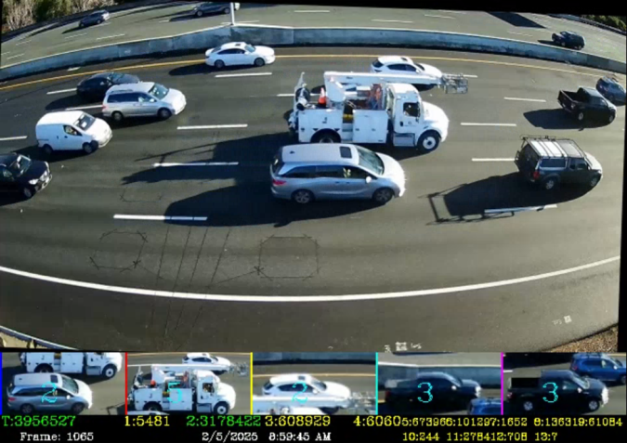

Bid Number: RFB-185-2547-2026
DOT AI-Enhanced Continuous Count Sites
Agency: Iowa Department of Management, Division of IT, on behalf of the Iowa Department of Transportation
Leetron Vision is please to provide the following five-year bid for providing artificial intelligence driven continuous count sites hear forth designated AICCS that meets the following specifications per the Iowa Bid Specifications.
Provided to: Provided by:
Iowa Department of Management Leetron Vision LLC
Attn: Business Services 37 Victorian Lane
200 E. Grand Avenue Ste. 100 Concord, NH 03301
Des Moines, IA 50309 Tax ID: 364718214
email: ITContracts@dom.iowa.gov email: leetronvision@gmail.com

This document contains Leetron Vision LLC proprietary information which has been provided to the Government with limited restricted rights and shall be protected from disclosure outside of the Government in accordance with the U.S. Trade Secrets Act, the U.S. Economic Espionage Act, and the U.S. Freedom of Information Act. This restriction does not limit the Government's right to use information contained in these data if they are obtained from another source without restriction. The data subject to this restriction are contained in all pages/sheets herein.

This document serves as the Leetron Vision bid details for the proposal response to the Iowa Bid Number RFB-185-2527-2026 for an Artificial Intelligence Driven Continuous Count Sites (AICCS).

Overview of the Services and/or Goods Offered
Leetron, a trailblazer in AI-based traffic counting for FHWA 13-class classification, sets the standard for accuracy and performance. Our technology delivers unmatched precision in AI-driven volume (well above 95%) and classification data (well above 90%) while remaining the most cost-effective solution in the industry. Trusted by over 30 DOTs and transportation agencies, Leetron’s systems are built for reliability in diverse climates, including those found in Iowa. Long-term deployments with agencies such as New York State DOT (six years of continuous operation) and Montana DOT (two years of continuous operation) demonstrate our proven performance.

Beyond accuracy, Leetron ensures seamless data availability through compatibility with leading post processing platforms like High Desert (Jackalope), MS2, Drakewell, and others. Our system not only meet, but in most cases exceeds Iowa’s RFB requirements. Additionally, Leetron is designed for simple installation by two-person crews with most installations on one side of the roadway, whether DOT staff, contractors, or subcontractors, ensuring easy deployment without specialized expertise. Leetron systems provide IR lighting for accurate night time sensing and for all types of weather conditions.

Lessons Learned in AI Traffic Counting

Through years of innovation since the original release of Leetron’s AI vehicle detection product, we have identified two key insights that challenge conventional traffic monitoring assumptions:
1. One model does not fit all. Individual permanent count locations require tailored solutions to leverage infrastructure options around varying roadway topography and ensure optimal performance and cost-effectiveness.
2. The 20/80 rule applies to AI-based traffic monitoring systems. A small portion of development effort is required to make the system work under normal conditions, while the majority of effort (80%) is dedicated to performance refinement across a wide range of weather and traffic conditions. This extra work is where Leetron provides superior classification data.
These insights led to the development of four specialized Leetron models, guaranteeing an optimal solution for each permanent count site. They also explain how Leetron was able to develop a prototype in just three months, launch a functional product in under two years, but needed six years to on abnormal conditions to address real-world challenges in AI-based traffic counting.

Leetron Permanent Count System Models
Resulting from years of research and to align with continued and emerging industry demands, Leetron has developed five distinct system models for permanent continuous count traffic monitoring. Each is designed to provide the highest quality FHWA volume and 13 classification vehicle type bins (live) traffic data while balancing site topography, component efficiencies, and cost. Each system model can be installed and operational in one day by a two-man crew of either DOT personnel, DOT contractors, or subcontractor.

Model | Offset | Cam Height | Camera Type / Qty | Cam-1 Max Lanes / Direction | Cam-2  Max Lanes / Direction | External IR |  |  |  | Max  Detect Distance  (From Camera) | Pwr
AI200 | 25’+ | 25’-35’ | PTZ / 1 | 4 / Bi | N/A | Yes |  |  |  | 100’ | AC
AI220 | 25’+ | 25’-35’ | PTZ / 2 | 3 / Unit | 3 / Unit | Yes |  |  |  | 200’ | AC
AI235 | 25’-35’ | 25’-35’ | Fixed / 1 | 4 / Bi | N/A | Optional |  |  |  | 100’ | Solar
AI250 | 12’-25’ | 25'-35’ |  |  | Fixed / 1 |  | 4 / Bi | N/A | Yes | 100’ | AC
AI252 | 12’-25’ | 25’-35’ |  |  | Fixed / 2 |  | 3 / Uni | 3 / Uni | Yes | 100’ | AC

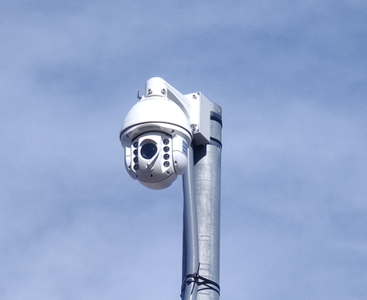
Model AI200
- System Benefits: The AI200 model can be installed on new or existing infrastructure with an offset of 25’ or greater, with an ideal distance of 30’ to 35’. The Pan Tilt Zoom (PTZ) camera provides traffic detection within 200’ when mounted at 25’ or higher. Additionally, the included camera has a dome wiper, heater and defrost options that provide added remote preventative maintenance functions to maintain ideal visibility conditions in all weather conditions. The system includes powerful external infrared lighting for clear nighttime visibility and consistent performance and data quality in the day or night. This model will detect up to four (4) lanes of traffic from an undivided roadway with one camera. Hard wired AC power (120 VAC) is required. Remote communication equipment is not included but can be purchased from Leetron should Iowa need a modem.
Figure 1 Model AI200 PTZ Camera
- Exclusions: Infrastructure, AC service and branch circuit, and any civil engineering work is provided by others for pole installation.
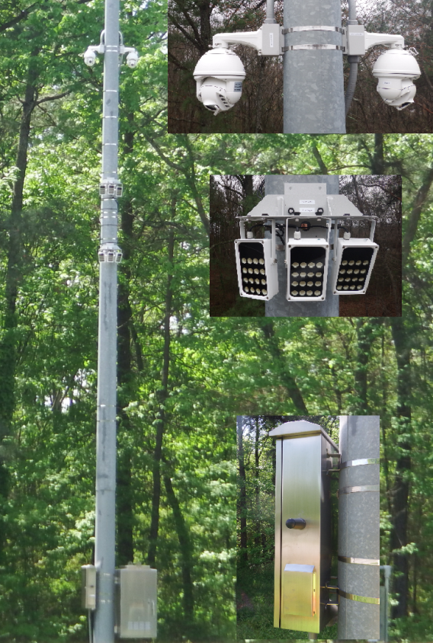
Model AI220
- System Benefits: The AI220 model can be installed on new or existing infrastructure with an offset of 25’ or greater, with an ideal distance of 30’. The two PTZ cameras provide traffic detection within 200’ when mounted at 25’ or higher. Additionally, the included camera dome wiper, heater and defrost options provide added remote preventative maintenance functions to maintain ideal visibility conditions. The system includes powerful external infrared lighting for clear nighttime visibility and consistent performance and data quality; day or night. This model will detect up to six (6) lanes of traffic from a divided roadway (3 lanes for each direction). Hard wired AC power (120 VAC) required. Remote communication equipment is not included. Remote communication equipment is not included but can be purchased separately if IA needs a modem.
- Exclusions: Infrastructure, AC service and branch circuit, and any civil engineering work is provided by others for pole installation.
Figure 2 ModelAI220

Model AI235
- System Benefits: This is a turn-key solar solution providing a base anchoring system, pole, 400W of solar power, 300 AH battery, and Leetron AI permanent count station. The small infrastructure footprint allows for full installation of an AI TMS where existing structures or power may not be available. Additionally, the installation can be performed without a bucket truck or man lift. The AI235 can be installed 25’ or more from the first lane of interest. The static camera will provide up to four (4) lanes of traffic detection on an undivided roadway. By default, the internal camera infrared is relied upon for nighttime performance. For farther distances or locations with no ambient lighting, the optional external infrared (as pictured previously) augments nighttime performance for sustained accuracy and data quality. Remote communication equipment is not included but can be purchased separately if IA needs a modem.
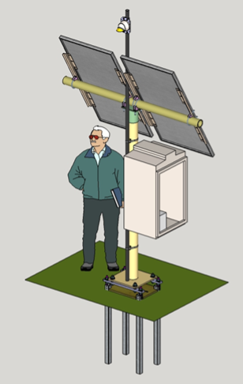
- Exclusions: Civil work and any required vegetation or tree removal for proper solar visibility is provided by others.

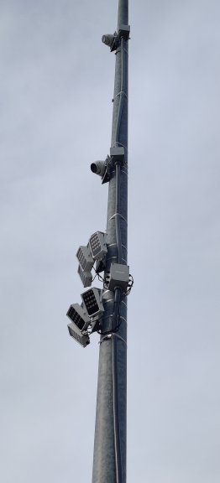
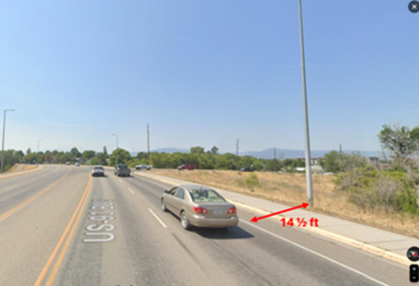
Model AI250
Figure 3 Model AI235
Figure 4 Model AI250
- System Benefits: Designed for offsets as short as 12’, the AI250 model is one of the most popular because of the performance in close proximity to the travel lanes. The system will work within 12’-25’ of the first lane of interest. This is ideal on bridges, urban areas, or limited DOT right-of-way. See Figure 4 Below. The static camera will provide detection up to four (4) lanes of bidirectional traffic within 100’**. Combined with the external infrared light, the highest data quality will be maintained day or night. Hard wired AC power (120 VAC) required. Remote communication equipment is not included but can be purchased separately if IA needs a modem.
**The AI252 model offers two (2) static cameras for coverage of up to six (6) lanes of bidirectional traffic.
- Exclusions: Infrastructure, AC service and branch circuit, and any civil work is provided by others.

AI Traffic Count Challenges
While AI introduces new capabilities that overcome the technical limitations of traditional in-road sensor systems, it also introduces new sources of variation due to weather, lighting, and traffic conditions. As a result, an AI-based system may perform well in one study but struggle in another, leading to consistency and reliability challenges. The ability to handle these variations is crucial for an AI system to be a viable traffic counting solution.

Although AI can effectively manage many conditions, certain AI-specific challenges require new methods and functionalities. A system’s ability to address these unique challenges is a key indicator of its consistency and long-term reliability in real-world applications.

The following list highlights some of the challenges Leetron has encountered over the years—some have been fully resolved, while others remain areas of active improvement. For additional details, please see the attachment “Data Elements.”

Weather Challenges | Classification Challenges | Special Condition Challenges
- Rain / Distorted Image  - Snow  - Fog  - Nighttime  - Shadows  - Sunrise/Sunset | - Dual Rear Wheel  - Vehicle with Trailer  - Lift Axle Position  - Special Vehicles  - Vehicle Occlusion | - Road Markings  - Reflections  - Special Combination Vehicles  - Traffic Congestion  - Extended Length Vehicles
This list summarizes some of the challenges Leetron has identified, overcome, and improved within its AI traffic monitoring system.

Leetron Technical Edge
While AI tools are widely available, not all AI-based systems are created equal. With 30 years of experience working with AI (previously known as neural networks) and a commitment to excellence, Leetron’s system stands technically advanced compared to newer market entrants.
This advantage is evident in three key areas:
- Ability to handle AI-specific conditions – Leetron has developed specialized solutions to address challenges unique to AI-based traffic counting, ensuring greater accuracy and reliability.
- Efficient processing power – Unlike many systems that rely on power-hungry GPUs, Leetron optimizes AI inference in software, leveraging PC-based processing to significantly reduce power consumption and minimize heat issues, resulting in highly reliable hardware.
- Superior energy efficiency for Solar System – While typical AI-based traffic counting systems require 1,000W solar panels, Leetron’s optimized design operates on just 400W, making it more cost-effective and more reliable system.

Detailed Work Plan
The RFB outlines the DOT’s desire to reinstate traffic data collection at several currently non-operational continuous count station (CCS), as well as work towards transitioning the remaining CCS to AI video-based technology. Our work plan is to provide a methodical approach suitable to the DOT’s priorities and timeline.

Overall Approach
- Initial Assessment and Planning
  - Work with the DOT to prioritize site selection(s) and timeline.
  - Conduct and review detailed assessments of the DOT’s initial site selections to understand specific requirements and constraints as well as determine the best Leetron system model (AI200, AI220, AI235, AI250 and AI252).
  - Develop a comprehensive project plan outlining timelines, resources, and milestones.
- System Implementation
  - Deploy the appropriate traffic counting models (AI200, AI220, AI235, AI250 and AI252) based on site-specific needs.
  - Ensure all hardware and software components are installed and configured correctly.
  - Conduct initial testing to verify system functionality and accuracy.
- Data Collection and Analysis
  - Begin real-time data collection to ensure the system operates under various weather and traffic conditions.
  - Assist with data delivery and ingestion to the DOT’s database or hosted polling platform.
  - Regularly analyze collected data to verify accuracy and reliability.
  - Implement any necessary adjustments to optimize performance.
- Maintenance and Support
  - Provide ongoing maintenance and support to ensure continuous system operation.
  - Address any issues promptly and efficiently to minimize downtime.
  - Offer regular software updates and hardware checks to maintain system reliability.
- Timeline
  - Turnaround time for furnishing an AI traffic monitoring station system is 3-6 weeks from the order confirmation.
  - Lead times for other services are contingent upon DOT prioritization of AI site selections.

Required Specifications:

A. Recorded Data Specifications that are provided for all Leetron Vision systems
1. Per-Vehicle Record Compliance: The evaluation results can be provided upon request.
- Vehicle count accuracy of 95% or better at any time of the day or night without any additional ambient lighting requirement
- Vehicle (individual) with 95% average accuracy or better at any time of the day or night without any additional ambient lighting requirement
- FHWA 13 vehicle types (live reported and edge processed) with 90% or better accuracy at any time of the day or night without any additional ambient lighting requirement
- Detail of every vehicle detected for any time of the recording periods with classification as obtained live and the detection lane of data
  - Per vehicle data edge storage with minimum time stamp of 1/10th second or more detailed
  - Binning capability of data to suit the DOT needs with any time period capability
  - Lane and direction of travel

B. Unit Specifications:
1. Monitoring Solutions
Leetron AI systems are capable of monitoring a range of distance and lane quantities, including inside and outside shoulders. A single camera system is capable of traffic detection in up to four (4) lanes within 100 feet of the camera. Use of a 2-camera system, such as the Leetron AI220, will monitor up to 6 lanes of bi-directional traffic (3 lanes per direction). The model with 2 PTZ cameras (AI220) will detect vehicles at distances up to 200’. All systems contain all necessary components for a successful installation/operation. All components are rated for exterior use and weather tested and specified to be compliance for all weather conditions.

2. Digital Camera Specifications:
Leetron AI systems are capable of monitoring 4 lanes plus any additional lanes such as the inside or outside shoulder. Distances of detection can be up to 200’. Leetron also provides optical zoom capabilities and image black out capabilities (see below image in figure 5) to remove side roadways, driveways and parked vehicles. This allows for a full customization of the site to optimize count accuracy. Ample storage space is provided (64 Gb) with every Leetron unit to store all five data types (including vehicle images and videos) for 60 days or more without needing to download or remove any files.

3. Edge processing of video/image feed: Yes.
- Web portal tool for viewing video feed from data on device: The Leetron software currently provides two methods for remote viewing video feed. One method is controlling the counter through a remote desktop where real-time video detection can be viewed. The second method is through a web connection that displays short video clips and counting information. Also, Leetron is currently working on developing a web/cloud portal to host system video viewing. Video files also can be viewed locally using the provided LCD screen that interfaces at the cabinet.
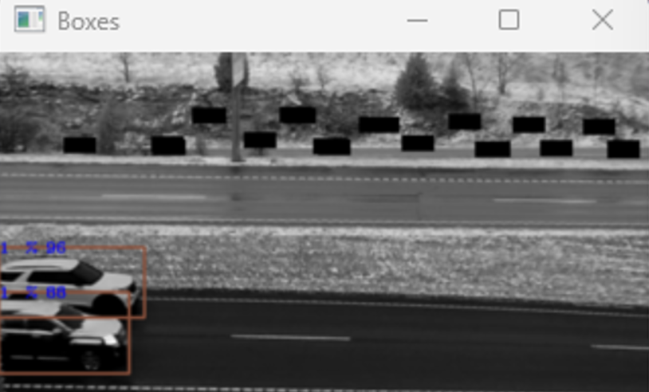
- Bounding box/indicator to portray an identified vehicle (preferred): As shown in figure 5, enabling the “show boxes” feature enables a second, smaller, video window that indicates a box around a detected vehicle. Additionally, the real time video monitor also displays real time vehicle image detections on the bottom of the video screen for easy verification. Concurrently, these images include vehicle class (number on the image), direction (vertical bar color on the left of the icon image) as shown in picture on the first page and lane associated with the given lane. This allows the user to easily verify operation and performance as well as whether any adjustments are necessary due to any degraded observations or traveling roadway changes (construction or other reasons). For further verification, Leetron provides the option to save each detected vehicle image (See attached architecture design for details). The file name for each image begins with the vehicle classification number and provides a quick and efficient method of performance verification and ground truthing capability.
Figure 5 Image with bounding box

4. Edge data creation and storage: Yes. By default, the Leetron traffic count system stores hourly videos, tabular data files, and per-vehicle-records. These various data files are open protocol, in human readable .CSV format. All data types are considered edge-based and completely instantly available for analysis, transfer or viewing at any time. The tabular data files are compiled in real time on the local system and readily available. The tabular data is stored at a user defined adjustable interval. The default interval is 15 min. The system has the storage capability to locally store 20 weeks of data with videos. Enabling other options, such as saving per vehicle images, will affect the storage capacity, however, there is option to set the data Retentions Days for added flexibility.

5. Transmission protocol: Yes. The various data files are compiled on the local system in real time and immediately available. The turnaround time for daily file auto-polling is dependent upon the capabilities of the DOT’s current traffic data management system. Within minutes of completion of a day’s count totals the data and videos are available for automated downloading and further processing. Currently, Leetron has four customers using Jackalope by High Desert as the post processing software to successfully ingest Leetron daily data files. Leetron is committed to working with the DOT and the auto-polling software administrators to ensure a seamless traffic data flow from edge system to database. Video files are available locally on the Leetron system for retrieval and review manually for use on an onsite laptop or for DOT for any purpose. All data can be downloaded and used for local purposes.

6. Operating temperature range of -40 to 130F: Yes. Leetron systems and components are rated for an operating temperature range of -40 to 130 degrees F. Over the last 5 years, our systems have been deployed in a wide range of climatic environments without temperature related issues. As examples of extreme ranges, we have systems installed in Alaska, Maine, Montana and New York where the winter temperatures are harsh. Conversely, installations in California and Florida have withstood the extremely hot temperatures in those regions.

7. Operating relative humidity of 5 to 95%: Yes. Leetron has successfully installed systems, with consistent performance, in regions with humidity ranging from 5 to 95% over 5 years of performance.

8. Warranties from sections 7.3 through 7.9 in the Master Agreement: Yes – agreed. Leetron will provide warranty of all equipment for 1 year as part of the purchase of said units and with the yearly license and warranty fee payment, units are fully covered for all hardware and items that fail to work except for batteries, acts of God or vandalism. All equipment will undergo a 50-hour burn in time and will be free from deficiencies. Leetron owns sole rights to supply all said hardware and software as provided with each unit. All items listed in a master agreement in section 7 are agreed to.

C. Installation and Site Specifications:
1. Installation on existing roadside and utility infrastructure (height of 20’ to 45’): Yes
The Leetron installation process is straightforward and can be accomplished by DOT staff (accounted for majority of the Leetron installations), DOT contractors or subcontractors. The installation outline is provided here, however Leetron will provide detailed instruction manuals and support (both individual and online) to DOT staff and its contract resources during any Leetron installation. Typically, installations can be completed with no specialized training in one day by a two-person crew. A bucket truck will be required and needs to be provided by the DOT or contractor for performing the installation.

2. Installation of lighting: Not required

For Leetron AI200 series systems, no external lighting is needed since all units use IR lighting to actively see at night and in inclement weather (including snow storms).

For AC-powered setups, the process involves mounting the camera(s), IR light(s) and Leetron pre-configured cabinet to the DOT owned pole or infrastructure. In most cases the equipment can be mounted using the Leetron provided heavy-duty hose clamps or customer provided stainless steel banding. Once mounted, connect the camera and IR light wiring, followed by the installation of an AC power line to the cabinet. If the model installed includes PTZ cameras, an advantage to these is that adjustments can be made remotely or from the ground.

For turn-key solar-powered setups, the installation involves setting the base plate anchoring system and pole. The camera, optional infrared, and solar panels can be mounted and wired on the pole prior to standing the pole eliminating the need for a bucket truck. Once the pole is stood, terminate the wiring in the cabinet. Please reference section Model AI235 for additional information.

With the equipment mounted and the system powered on, the final step step is to configure the system software. This is a simple three-part process using the Leetron installation guide:
- Setup the PTZ cameras using the embedded user interface in the camera.
- Within the Leetron software, enable the desired settings and enter the DOT specific information pertaining to the CCS location.
- Click ‘Start’ in the Leetron software and it will begin the automated configuration process of detecting the travel lanes and seamlessly transition to recording video and traffic data.

3. Solar and hard-wire model can be used: Yes
Models AI200, AI220, AI250, and AI252 are for hard-wired 120 VAC.
Model AI235 is for locations where solar power is necessary.
Leetron does provide solar options. AI235 is the turn-key system. Leetron also provide an option where customer provide the solar power, cabinet, pole and cellular communication.

4. Solar power only on the exiting pole location. Yes
Leetron recommends 300 Ah batteries and a 400 watt solar array as a minimum for successful operation under normal lighting conditions. If less sunlight is present then a 500 or 600 watt array may be needed or more batteries present in the cabinet for power needs when 5 or more little sunlight days are present. Leetron can based on local input from staff provide easily a system that would provide a minimum of 7 days or operation with little sunlight to charge the panels.

Leetron realizes it’s not always possible to meet ideal circumstances when trying to utilize existing infrastructure for a cost-effective integration of an AI-based traffic detection system. While Leetron considers 30’ as the ideal distance for both offset and height measurements for its systems, there is flexibility in distance combinations when using any of the Leetron models while maintaining accurate and quality data. Ensuring flexibility is what led to Leetron’s, most recent AI250 and AI252 models, which is to accommodate the use of existing pole or sign with an offset very close to the first lane of interest. The AI250 system has been implemented at locations with offsets as short as 12 feet and met performance expectations. Leetron will always assist in site assessments and provide system selection guidance and support for successful and quality data collection.

D. Technical Support Requirements
1. Assistance with Installation and Setup plus Training: Yes The success of the Leetron system and the quality data is only possible through the knowledge and confidence of the end users. To that end, Leetron is committed to training and continues guidance support in all layers of system ownership: First step is the installation and guidance with setup and configuration then followed by maintenance and troubleshooting. At the start of the contract Leetron will provide initial training through virtual web meetings and on an as-needed basis throughout the life of the contract. If in person training or installation assistance is needed or desired Leetron would be happy to work with staff to provide this support on the first site. As field installations progress, Leetron will have personnel on standby to answer questions and remotely access the system to verify performance and fine-tune the system setup. Additionally, all Leetron manuals will be readily available for all staff. Software training that is provided virtually and thru share screen experiences is available at no charge for one on one training of all staff who will need to setup systems, monitoring sites, download data and potentially change settings should this be necessary. Leetron has gone through this process with over 30 state agencies with successful installations.

2. Real-time accessibility to each device for troubleshooting, calibration, and live video monitoring.
Yes. When a network connection is available, such as through a cellular modem, it is possible for the end user to remotely connect to the Leetron system with access to all the same functions as if present on site. When remotely connected, it is possible to monitor real time video and performance, download data, troubleshoot issues, adjust any settings, etc.
4. Ongoing technical support available within 2 hours of issue identification (preferred)
Leetron will provide on-call personnel for ongoing technical support during normal Iowa DOT business hours. Typical response times are less than 2 hours. Under special circumstances, it may be possible to coordinate afterhour’s on-call support.

